Keratoconus

What is Keratoconus?
Keratoconus (pronounced keh-rah-toe-cone-us) is an eye condition that affects the cornea on the front of your eye. It usually starts in your teens or 20s and generally worsens over time, finally becoming stable by the time you reach 40. The word “keratoconus” literally means “cone-shaped cornea”. As the condition progresses, it causes changes in the regular shape, strength and thickness of the cornea. The way this affects your sight will depend on the severity of these corneal changes, so that some people experience fewer sight problems than others. It is usually present in both eyes, although one eye may be more affected than the other.

There are various strategies that can manage or treat keratoconus and your ophthalmologist (hospital eye doctor) can explain which is the most appropriate option for you at every stage.

What is the cornea?

The healthy cornea
Your cornea is important for sight. A healthy cornea has a regular dome-shape and is made up of a number of layers. It is normally strong, smooth, and transparent.

The surface of the cornea is very sensitive. Its front surface, the epithelium, contains many nerve endings which can detect even the smallest piece of dirt or fluff.

The largest, middle section of the cornea is called the stroma, and it’s made up of many regular-shaped bundles of connective tissue, known as collagen. These collagen bundles are firmly joined together, giving the healthy cornea its strength. The regular arrangement and spacing of these collagen bundles are extremely important for keeping the cornea clear.

A clear cornea allows light to pass through it, while its regular domed shape enables it to focus this light to give you clear vision. As light enters your eye, it is focused by two structures, first by the cornea and then by the natural lens inside your eye. It’s your cornea that focuses light the most, while the natural lens fine tunes the focus onto the retina at the back of your eye. The retina then converts this light into electrical signals which the brain interprets to give us our sense of sight. The more accurately light is focused onto your retina, the better the quality of vision you’ll have.

The following diagram shows the layers within a healthy cornea which has a regular, outwardly domed shape. The layers of the cornea are labelled innermost to outermost as endothelium, Descemet’s membrane, stroma, Bowman’s layer and epithelium.

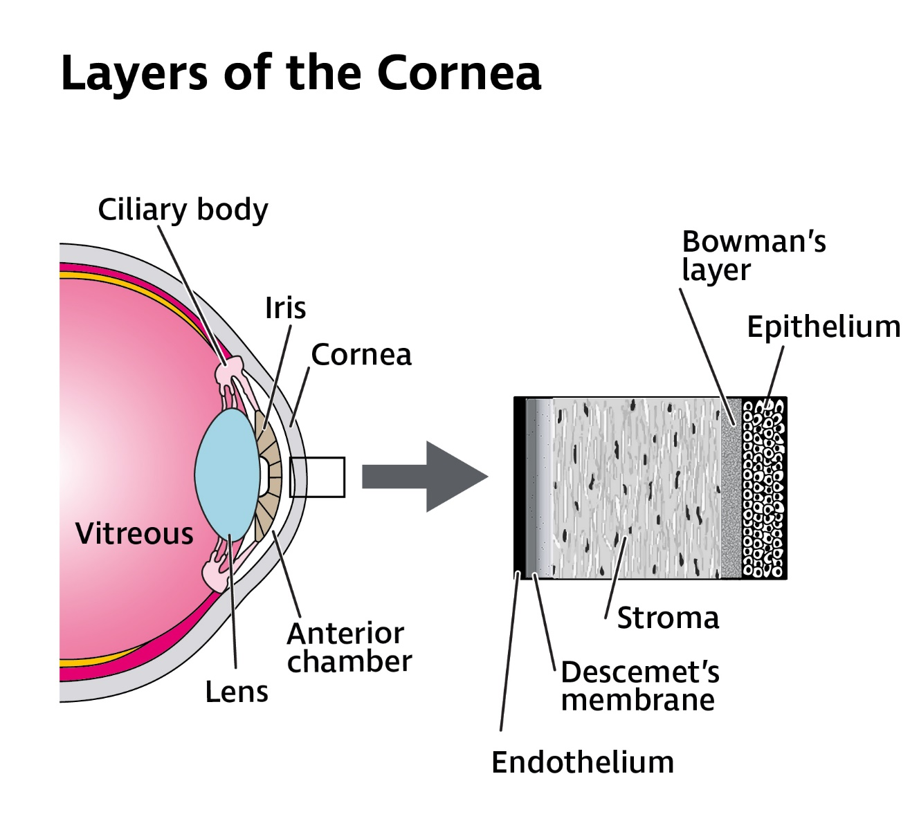

The cornea with keratoconus
If you have keratoconus, the collagen bundles are affected within your cornea, so that the cornea becomes weaker and thinner nearer its centre, or just off centre. These changes in corneal thickness lead to an outward bulging (distension), causing an irregular cone-like corneal shape to develop. This process of corneal thinning and distension is called corneal ectasia.

However, throughout your 30s, the collagen bundles in the corneal stroma naturally crosslink together to form stronger bonds between themselves. This natural crosslinking process stiffens your cornea and slows down the progression of your keratoconus, making the condition more stable by the age of 40.

The following diagram shows a healthy cornea and a cornea with moderate keratoconus. The cornea, iris and lens are labelled within each eye. The healthy cornea has a regular shape, thickness and curvature, whereas the cornea with keratoconus has an irregular, outwardly cone-like shape where the corneal thickness is reduced.

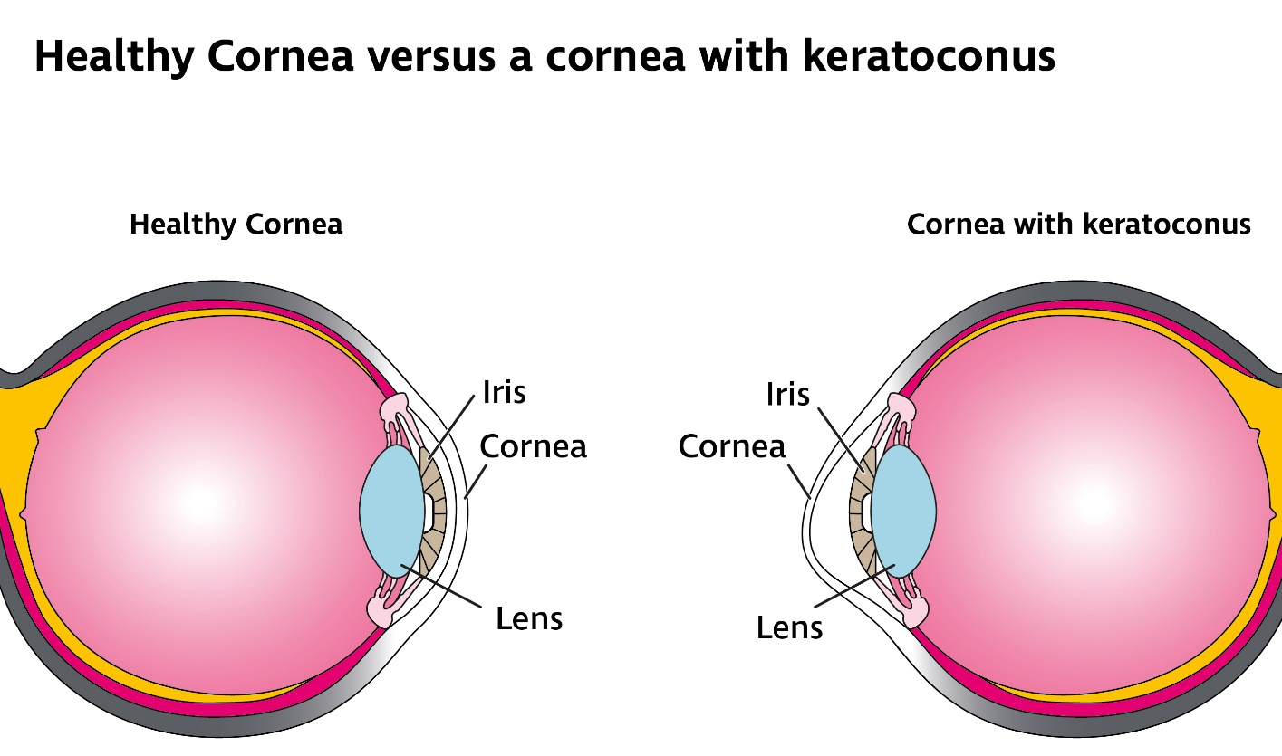

What causes keratoconus?
The cause of keratoconus is not completely understood. It’s not caused by an infection or inflammation. It’s thought that a person’s genetic make-up and environmental factors, such as persistent eye-rubbing, may play a part in developing the condition. It affects men and women equally and is more common in non-Caucasian people.

It is usually diagnosed when someone is in their late teens or early twenties. When it is diagnosed, keratoconus can normally be seen in both eyes, but usually one eye is more affected than the other.

Keratoconus is not considered to be an inherited condition but for around 10% (1 in 10) of people who have keratoconus, it does affect more than one member of their family. However, most people have no family history of the condition.

It’s possible that people who have allergies might be more likely to develop keratoconus. Allergies can cause your eyes to become itchy and uncomfortable, making you more likely to rub them.

If someone rubs their eyes a lot over a long period of time, this could make their cornea weaker and more at risk of developing keratoconus, although this does not happen for everyone. If you do experience allergies that make your eyes itchy, it is important to seek treatment which can help you stop rubbing them too much.

Some research also suggests that corneas affected by keratoconus may not be as good at healing from everyday wear and tear and may have less of the important fibres and links between them that give the cornea its strength.

Can other medical conditions lead to keratoconus?
Most people with keratoconus do not have any other eye condition or medical concern. However, some syndromes affecting general health do carry a greater likelihood of someone having keratoconus and these include Down’s syndrome, Ehlers-Danlos syndrome and Marfan’s syndrome. It is therefore important for people with these syndromes to have their eyes examined regularly after diagnosis to assess all aspects of eye health, including keratoconus.

Some people with particular eye conditions also have the potential for keratoconus to develop. These include aniridia, Leber congenital amaurosis (LCA), retinitis pigmentosa (RP) and some allergic conditions that cause you to rub your eyes persistently.

How does keratoconus affect sight?
Keratoconus can affect different people to different extents, but it does not cause blindness. It tends to progress more quickly when it starts at a younger age, and it can continue to worsen until a person is in their mid-30s when it should begin to stabilise.

In the very early stages of the condition, your vision may not be affected very much at all. However, as your keratoconus progresses and your cornea changes its shape, your vision will become more blurred because light entering your eye isn’t focused as accurately on your retina as it needs to be to give clear vision. Some of the blur from keratoconus is due to a focusing problem called ‘irregular astigmatism’, which cannot be corrected with spectacles, and which results from the irregular and uneven corneal shape.

The corneal bulging of keratoconus can also make your eye become more short-sighted (myopic). Being myopic means that distant objects will appear more blurred to you, while objects nearer to you may be clearer.

Depending on the degree of your keratoconus, you may be more sensitive to light (photophobic) and experience glare, leading to discomfort and difficulty seeing things in brightly lit conditions. Glare and photophobia are caused by the irregularity of the cornea, which scatters light as it enters your eye. Similarly, you may also experience ghosting (a secondary image around what you see) and see halos around lights, which may make it more difficult to see clearly; for example, when driving at night facing oncoming headlights and street lighting. However, everyone is different, and some people will experience these symptoms to a greater extent than others.

If you’re affected by light sensitivity, making conditions around you less bright will help. This may mean wearing sunglasses and brimmed hats outside and reducing the lighting in the room when inside. If using devices such as phones, tablets and computers is uncomfortable, reducing the brightness of the screen can also help.

You can find more information about light sensitivity and glare on our website rnib.org.uk/eyehealth or by calling our Helpline 0303 123 9999 and requesting our information about light sensitivity.

How is keratoconus diagnosed and monitored?
Your optometrist (optician) or ophthalmologist can carry out a number of tests to diagnose keratoconus and measure any changes to the shape of your cornea over time. These tests include:
- Refraction: This is the part of your sight test that assesses what glasses or contact lenses are needed to give you the best possible vision.
- Slit lamp examination: This specialised microscope may detect certain structural changes in the cornea under a high magnification.
- Keratometry: This measures your front corneal curvature, showing how steep your cornea is and how much corneal astigmatism there is.
- Computerised corneal mapping (corneal tomography): This is used to create a 3D image of your cornea, showing its varying shape and curvature, as well as identifying where these variations are located on the cornea.
- Corneal pachymetry: This test measures the thickness of your cornea.

How is keratoconus usually managed?
Early keratoconus is usually picked up by your optometrist during an eye examination and they will usually refer you to an ophthalmologist in a hospital eye clinic for further assessment. It is not normally essential to be referred urgently, as keratoconus can take months, in some cases years, to progress. Your ophthalmologist will monitor your condition over a period of several years to check for signs of progression.

Glasses and contact lenses
Where keratoconus is mild, you may achieve a good level of vision just by wearing glasses. However, if your cornea continues to become steeper and more cone-shaped you will need more powerful lenses to correct your sight. If these changes happen more rapidly, your glasses prescription could alter more frequently too, meaning you may need to change your glasses more often. Stronger, more powerful lenses can make glasses thicker and heavier and they can also cause your vision to be distorted, making ghosting more obvious, particularly when you are looking through the edges of the lens. This means there may come a time when your vision using glasses isn’t as good as it could be, and that your sight is better when you wear contact lenses.

Contact lenses sit on the front of your eye, providing a regular front surface on the cornea and masking the irregularities due to keratoconus. A thin layer of your tears, known as the tear film, remains between the lens and the corneal surface, and this helps to keep the lens in place.

Although contact lenses do not slow down the rate of progression of keratoconus, their specialised design corrects irregular astigmatism better and can often improve sight further when glasses no longer work as well as they once did.

What contact lenses options are available for keratoconus?
Contact lenses are made of specialised plastic materials which are suitable for your eye to wear. They allow oxygen to pass through them, which enables your cornea to breathe.

Contact lens wearers with keratoconus usually wear rigid gas permeable (RGP) lenses. However, there are various types of specialised contact lenses that can be fitted. Your optometrist will be able to advise which is the best option for you.

- Soft contact lenses (hydrogels) can be specially designed for keratoconus. These are only usually offered if your keratoconus is mild and there is relatively little corneal irregularity. They may be more comfortable than rigid contact lenses. They are thicker than regular soft lenses so that they mask a mildly irregular cornea better, and they are a larger diameter than RGP contact lenses. However, as your keratoconus progresses, it’s unlikely you’ll be satisfied with your vision when wearing soft lenses because they are not as effective at masking significant corneal irregularities as RGP lenses.

- An RGP lens sits on your cornea, providing a regular front surface to the eye. The lens material, design and fit enable the lens to mask the irregularities of your cornea to improve your vision when the lenses are worn. The thin layer of tears between an RGP lens and the cornea acts like a “liquid lens”, which also helps with focusing the light as it enters your eye, helping to make your vision clearer. The level of improvement in vision when wearing an RGP lens will vary from person to person depending on the severity of their keratoconus.

You would need to adapt gradually to RGP lenses. However, after building up tolerance to them, most people can wear them for a full day, as advised by their optometrist. Glasses can still be used as a back-up to RGP contact lenses. Some people find they’re only able to wear their lenses for a limited amount of time or they may feel that the discomfort never really goes away. If you can’t wear RGP lenses, there are alternative contact lens types your optometrist may suggest for you and these include:
- Piggybacking, which involves wearing a soft contact lens on the cornea with an RGP lens worn on top. The aim is to provide better vision from the RGP with the benefit of soft lens comfort underneath it. Your vision may not be quite as good as with an RGP lens on its own. Piggybacking could be more costly, as there are two lenses worn in the same eye rather than just one.

- Hybrid lenses, which have a RGP centre and softer outer ring to make them more comfortable. Sometimes, these can be difficult to fit and some people find it a challenge to insert and remove these lenses. Careful monitoring by your optometrist is recommended with this lens type as the oxygen supply getting through to the cornea may not be sufficient, which can cause new blood vessels to grow into the cornea.

- Scleral and semi-scleral lenses. The sclera is the white of your eye. A scleral lens is a large, made-to-measure RGP lens that sits on the white of your eye, rather than on your cornea. A semi-scleral lens is slightly smaller than a full scleral lens, but larger than other types of contact lens. These lenses are generally used when keratoconus is more advanced.

Scleral and semi-scleral lenses can be more comfortable to wear, as your sclera is less sensitive than your cornea, and your eyelid won’t feel them as much as a smaller RGP lens, but they can be more difficult to fit.

How do I get my contact lenses?
Contact lenses are fitted by optometrists who are experienced in managing keratoconus, either within a high street practice or more usually within a hospital eye clinic. Your optometrist will examine the health of your cornea and take measurements of the front of your eye. They will be able to discuss the fitting process with you as well as the contact lens options that are appropriate for you. Your optometrist will try some contact lenses in your eye to help them to decide on the best lens to order for you. This process can take a lot of time and it requires patience to get the best possible lens fitting for you. This is not always achieved at the first fitting session. The fit of your lenses can change, even from day to day, so it’s important to work with your optometrist to find the lens that provides you with the best compromise for vision and comfort. You’ll also be advised how long to wear your lenses each day to minimise the problems of overwear. Even if your lenses feel fine, it’s important to follow the guidance you’ve been given on wearing times.

Will my contact lenses always be comfortable?
Contact lenses can make your eyes feel gritty, irritated and uncomfortable. Your eyes may feel dry, or they may water at times.

Other factors, such as problems with allergy or blepharitis (inflamed eyelid margins) commonly make these symptoms worse and can often be treated to help you to wear your contact lenses more comfortably. Your optometrist or your ophthalmologist will examine the surface of your eye and advise you about any additional treatment you may need.

Your optometrist may also suggest trying alternative lenses to improve comfort.

You can find more information about the causes of dry eye symptoms on our website rnib.org.uk/eyehealth or by calling our Helpline 0303 123 9999 and requesting our information about dry eye.

Can I get help with the cost of my glasses and contact lenses?
You would have to pay for your glasses or contact lenses unless you are eligible for help with these costs under the NHS voucher scheme. For example, the NHS voucher scheme can help if you are under 16, or if you are under 19 and in full time education, or if you are eligible based on certain financial benefits you receive. Your optometrist would be able to advise you further about your entitlement to help with these costs.

When glasses no longer correct your vision satisfactorily, but contact lenses do, your ophthalmologist or optometrist would be able to say that it is ‘clinically necessary’ for you to wear contact lenses instead of glasses.

Contact lenses that are prescribed as ‘clinically necessary’ within NHS hospital contact lens clinics can be prescribed for you at a set cost per lens. This means you pay a set price for any contact lenses that have been prescribed for you. This set price is reviewed every year on 1 April by the Department of Health and your optometrist will be able to tell you about the current cost at your contact lens fitting. However, if you are eligible for financial support under the NHS voucher scheme, you will receive help towards these costs. This usually covers you for a period of 6 months if you need further changes in your prescription.

What happens if I lose or damage my contact lenses?
When contact lenses are clinically necessary, there’s no charge for replacing any lost or damaged lenses if you’re under 16, or under 19 and in full time education.

If you’re over 16 and not in full time education, it’s likely that you’ll have to pay for replacement lenses if they’re lost or damaged, even if you were entitled to help with the initial cost of your contact lenses under the NHS voucher scheme. Your hospital department will be able to confirm if you need to pay for replacement lenses in these circumstances.

Can I get help with the cost of contact lens solutions?
Unfortunately, there is not much help available for the cost of contact lens solutions, so generally, you will be responsible for buying your solutions yourself. Your hospital eye clinic might provide you with a prescription for one month’s supply of contact lens solution at each clinic appointment, but you won’t be able to continue to get your solutions on prescription otherwise. Your GP is also not able to prescribe contact lens solutions for you.

Are there any treatments for keratoconus?
If your keratoconus is progressing (worsening), there are treatment options available, such as corneal crosslinking (also known as CXL or C3R) and intracorneal ring segment (ICRS) implantation. If your keratoconus is more advanced, your ophthalmologist may suggest having a corneal transplant (known as keratoplasty).

Corneal crosslinking (CXL)
Corneal crosslinking is the only clinically proven treatment that can stop keratoconus from getting worse by stabilising the shape of your cornea, and it is available on the NHS.

Studies have shown that CXL is a safe treatment and that it can prevent progression of keratoconus in over 90% of cases. It can also be repeated, if necessary.

This treatment is most effective in treating keratoconus in its early stages, as it will be more likely to stabilise your corneal shape, providing a better level of vision for the longer term.

Before CXL became an available treatment, at least 20% of people (one in five) who had progressive keratoconus would eventually need a corneal transplant to improve their vision. Now that CXL is more widely available, corneal transplantation for advanced keratoconus is becoming less common.

How does CXL work?
CXL works by using riboflavin drops (vitamin B2), ultraviolet A (UVA) light and oxygen to strengthen the cornea and prevent further changes in corneal shape and irregularity. It is usually offered as a treatment when there are signs your keratoconus is progressing. The treatment aims to halt keratoconus progression so that your vision does not worsen any further.

The cornea is made up of fibres of a protein called collagen which are linked together in such a way as to give the cornea its rigidity and strength. In keratoconus, this linking may be weaker, allowing your cornea to bulge outwards in an irregular shape. CXL strengthens the links or bonds in the substance between the collagen fibres, making the cornea stiffer and less likely to change its shape. CXL is less likely to be required to stabilise your corneal shape in keratoconus as you get older. This is because crosslinking occurs naturally as you age, and the corneal shape in keratoconus typically stabilises by your mid-30s.

Your ophthalmologist will consider your age, the shape, thickness and irregularity of your cornea and whether your keratoconus is progressing before advising you if CXL is an appropriate treatment for you.

What happens during CXL treatment?
The treatment is carried out by an ophthalmologist or specialist ophthalmic nurse as a day case, meaning you will not usually have to stay in hospital overnight, although you may be in the clinic for several hours. The procedure typically takes about 15 minutes per eye, but treatment duration varies depending on the type of CXL procedure you are having. You will usually be awake throughout and be asked to lie flat. Anaesthetic drops are used to numb your eye so that you don’t feel anything, and a special clip called a speculum is used to keep your eyelids open to stop you from blinking during your treatment. The front surface of the cornea, the corneal epithelium, is gently removed to expose the stroma beneath. This is known as ‘epithelium off’ CXL. Riboflavin drops are then instilled into your eye over several minutes before UVA light is shone at your cornea. The amount of UVA that is needed for the treatment to work can be delivered more intensely in either 8 minutes (rapid or accelerated CXL) or more gradually in 30 minutes (standard CXL). It is now much more usual to be offered rapid CXL, but your ophthalmologist will tell you which type of CXL is used in your clinic.

If it’s required, you may be offered treatment to both eyes at the same time. You’ll be fitted with a soft contact lens, known as a “bandage lens”, which you will be required to wear continuously for several days until it’s removed by your ophthalmologist at your follow up appointment, probably within the first week of your treatment. This bandage lens protects your cornea and promotes its healing but if it falls out before your follow up appointment, you should throw it away. You should not put it back into your eye as this can lead to infection and affect the healing process.

For some people, where the quality of their vision is already affected by their keratoconus, combinations of CXL and a specialised laser treatment called TransPRK can be used. This combination of treatments stabilises the keratoconus to prevent further deterioration and helps to make the corneal shape more regular as well. Your ophthalmologist will be able to advise you about which treatment is most suitable for your keratoconus.

What happens after my CXL treatment?
It’s important that you don’t drive immediately after your treatment, so you’ll need to arrange for someone else to drive you home after your procedure.

You’ll be asked to put different drops in your eyes over several days which will control inflammation, minimise the risk of infection and lubricate your eye. You’ll also be given some anaesthetic drops to be used within the first 24 hours to minimise your awareness of pain. All of your drops should be used exactly as your ophthalmologist advises to encourage your eye to heal well. You’ll also be able to take pain relief and may also be prescribed tablets for this by your ophthalmologist.

Everyone is different so your recovery experience may not be exactly the same as someone else who has had CXL. You will be more sensitive to light (photophobic) following treatment and after a few hours, when the local anaesthetic has worn off, your eye will start to feel gritty and sore. It will look red, and your vision will be blurred. These symptoms may last for several days. How much pain you feel will be very individual, with some people feeling a much greater level of discomfort than others. Wearing sunglasses, sitting in a darkened room, or closing your eye can help you feel more comfortable. The pain in your eye may last over the first two or three days before settling down. After this time, your eye should start to feel less painful as your corneal epithelium is healing. The epithelium should be completely healed one to two weeks after your procedure and by the end of the first week, you should be pain free.

If you notice an increase in pain again after your eye has become more comfortable, you should contact your eye clinic or A & E (accident and emergency) immediately as, although rare, this may be a sign of infection.

Around two weeks after your treatment, your vision should be stabilised and have improved or returned to how it was before CXL. Your ophthalmologist will advise you when it is safe to wear a contact lens again. This is usually once they can see that the corneal epithelium has fully healed. You will need to build up your wearing time again and may find using your lubricating drops more often helps.

You’ll be given a follow up appointment to see the ophthalmologist a few days after your procedure and another appointment a couple of months after that. You will also be monitored with further eye clinic appointments over the next few years to ensure your corneal shape remains stable.

Can I have CXL more than once in the same eye?
Most people only ever need one treatment in their eye but if the first treatment does not stabilise the cornea adequately, CXL can be repeated on the same eye again if necessary.

Do I need to take time off work?
You will be advised to take at least one to two weeks off work, depending on what kind of work you do. This is so you can recover and follow your aftercare instructions, putting your drops in your eye as often as advised. Good compliance with these instructions will increase the chances of a successful outcome to your treatment. Using a computer will not damage your eye, but if you are trying to use one continuously with an eye that is painful, blurred, and sensitive to light, computer work will lead to eyestrain and greater discomfort. When you do return to work and if you must use a computer for a lot of the time, taking regular breaks and regularly putting your lubricating drops into your eye will help to keep your eye more comfortable.

Can I drive after my treatment?
You should not drive until your ophthalmologist tells you your vision is good enough to meet the legal requirement to do so. This will be at least a week after your treatment but may require you to wait until you can resume contact lens wear after about two weeks. Your ophthalmologist will be able to advise you further about this.

Can everyday activities damage my eye after treatment?
Within the first few weeks of treatment, your vision may still be blurred and may not stabilise completely for several months. This may lead to eyestrain and fatigue with some tasks. This is normal and is not a sign that your treatment hasn’t worked. Reading, watching TV or using technology such as phones, tablets and computers does not damage your eye or affect the outcome of your CXL. However, in the first few days after your treatment, you may find these sorts of activities uncomfortable and so you may prefer to avoid them.

You can wash your hair and shower with care, but avoid getting water or soap into your eye, particularly in the first couple of weeks after treatment, as this can cause irritation, lead to infection, and affect the healing process.

You can normally resume sporting activity as soon as you are comfortable after treatment. Swimming should be avoided for at least 2 weeks after treatment.

You should also avoid dusty or smoky environments for the first couple of weeks after treatment and if anything does go into your eye, for example, an eyelash, you should wash it out using your lubricating drops. You must not poke your eye with your finger, and you must not use tap water to wash it out.

You shouldn’t wear make up around the eye for at least the first week after treatment to avoid irritating your eye, especially when removing your make up. Try not to rub your eye in the first couple of weeks, even if they are itchy. Instilling your lubricating drops can help soothe your eye if it feels itchy or uncomfortable.

If you are in any doubt as to what activities you should or shouldn’t do after treatment, your ophthalmologist is best placed to advise you.

Are there any risks from CXL treatment?
Overall, CXL is a safe treatment, but no procedure is completely risk free and your ophthalmologist will discuss with you all the potential risk factors before you consent to having your treatment. These complications include:

Discomfort
You may notice that your eyes feel gritty or dry in the early period after treatment. Lubricating eye drops can be used as required for comfort.

Your vision gets worse
A very small number of people (around 3%, or 3 in 100) experience complications after their treatment that makes their vision worse. This can be due to:
- Corneal scarring
- Corneal haze
- Increase in corneal irregularity
- Infection

If your vision gets worse after CXL, you may be offered a corneal transplant to improve your vision. Your ophthalmologist is best placed to advise if this is an appropriate next step for you.

When should I see my optometrist after my treatment?
Your spectacle prescription can be variable for several months after your treatment, so you’ll be advised by your ophthalmologist as to when it is appropriate to update your glasses. You can visit your own optometrist for this when the time is right.

Intracorneal ring segments (ICRS)
If your keratoconus has progressed beyond the stage at which combined CXL and TransPRK are helpful, intracorneal ring segments (ICRS) can be used to improve your vision. This is typically at the stage when your vision in glasses is no longer at the driving standard.

ICRS are thin plastic semi-circular rings which are implanted into the corneal stroma. The aim of this treatment is to flatten the central cornea and give it a more regular shape. For some people, this can allow for a better contact lens fit or better vision with glasses.

The procedure involves implanting two C-shaped rings in the cornea under local (eyedrop) anaesthetic. A very precise laser called a femtosecond laser is used to create a circular channel within the cornea, into which the implants are placed.

There is no clinical evidence that the improved corneal shape will be maintained with ICRS alone, so you might also be offered CXL a few months later, as a follow-on procedure, to “hold” the corneal shape achieved by the ICRS. CXL after ICRS can prevent your keratoconus from continuing to get worse, so that your implants will be more beneficial in the longer term.

For the right patients, ICRS have been found to be a safe treatment that can help to improve vision in about 2 out of 3 people who undergo the operation. ICRS may help avoid the need for corneal transplantation, but where they do not work or where your keratoconus is already advanced, your ophthalmologist is likely to suggest a corneal transplant as the next step.

Complications of keratoconus - corneal hydrops
Corneal hydrops is a rare complication of keratoconus which gives your cornea a milky, cloudy appearance and makes your vision get worse very quickly. It occurs when the aqueous fluid from inside your eye enters your corneal stroma through breaks in Descemet’s membrane, a layer at the back of the cornea that has become stretched as your keratoconus has progressed. This fluid usually enters the cornea suddenly, causing sudden swelling and blurring of vision, even when wearing a contact lens. Your eye feels more uncomfortable, even painful, and becomes red and watery and your sensitivity to light increases.

These breaks in your cornea will usually take two to three months to heal and you’ll be advised not to wear your contact lenses while your eye is recovering as this can cause further complications. If you feel any discomfort or pain, your ophthalmologist can give you eye drops to make your eye feel more comfortable. They might also suggest injecting a special gas behind your cornea to plug the breaks in Descemet’s membrane and stop further aqueous fluid from passing through it.

Once the breaks have healed, most people find that their vision improves again. You may need a new contact lens to be fitted after hydrops, as your cornea may have changed shape during its recovery.

Some people find contact lenses are more comfortable and stay in better after having hydrops. This is because hydrops can cause scarring which flattens the cornea. Less commonly, you might be left with scarring that could make your vision in that eye worse, so that a corneal transplant is needed to improve your sight.

Corneal transplant (keratoplasty)
With the introduction of CXL, the number of people with keratoconus requiring a corneal transplant is expected to reduce. However, corneal transplantation remains a good treatment option if you already have advanced keratoconus.

A corneal transplant is surgery to remove all or part of a damaged cornea and replace it with healthy, clear corneal tissue from the eye of a donor who has died. It is possible to carry out transplants which replace all, or only some corneal layers in the treatment of keratoconus. Corneal transplants are very successful in treating keratoconus. After a corneal transplant, even when your eye has healed and your vision has stabilised, it’s still likely you’ll need to wear glasses or contact lenses to get the best possible vision.

There are two types of corneal transplant which are appropriate for treating keratoconus. Your ophthalmologist will be able to tell you which type is best for you:
- Deep anterior lamellar keratoplasty (DALK), where only the outer layers of the cornea are replaced. The outermost corneal layers from a very small area in the centre of your cornea are removed, leaving behind Descemet’s membrane and the innermost endothelial layer. DALK is not appropriate if you’ve had hydrops, as this indicates Descemet’s membrane layer in your cornea is weakened.

A specially prepared ‘button’ of donor tissue, which has been cut to fit into your cornea precisely, is then put in place, replacing the outermost layers that have been removed.
- Penetrating keratoplasty (PK) is a ‘full thickness’ transplant. This means all the layers of your cornea are replaced by a donor cornea. PK is more likely to be offered if you have already had a DALK transplant which has not worked, or if there is scarring or damage to the innermost layers at the back of the cornea.

In both types of transplants, the corneal tissue is held in place by tiny sutures (stitches). If you have had a DALK procedure, these sutures remain in place for at least six months after surgery. It can take at least this amount of time, for your vision to improve to its best level. If you have a PK procedure, the stitches will be left in place for at least a year. It can take up to 18 months after your transplant for your vision to reach its best possible level.

Around 95% of people whose keratoconus is treated with PK find their transplanted tissue lasts at least five years or more and around 50% last 20 years. DALK transplants may last for longer and have an even lower risk of being rejected when compared to PK transplants.

You can find more information about corneal transplants on our website rnib.org.uk/eyehealth or by calling our Helpline 0303 123 9999 and requesting our information about corneal transplants.

Coping
It’s completely understandable to be upset when you or a family member are diagnosed with keratoconus and it’s normal to find yourself worrying about the future and how you or your relative will cope. You may find yourself wondering how this eye condition will affect your employment or your education and what opportunities may now be affected in your future.

Support from RNIB
It can sometimes be helpful to talk about these feelings with someone outside your circle of friends or family. By calling our RNIB Helpline, you are no longer alone. We can support you at every step, putting you in touch with the advisors you need from any of our supportive teams. From support with your education to advice on your employment, from using assistive technology to understanding more about your eye condition, we are here to help. Our Counselling and Well-being team is also available to provide the emotional support you may need. Your GP or social worker may also find a counsellor for you if you feel this might help.

The Eye Care Liaison Officer (ECLO)
You may think of further questions about keratoconus on your way home from hospital or in the days and weeks following your diagnosis. There is someone to turn to with these questions. Your eye clinic may have a sight loss advisor working alongside the doctors and nursing staff. This advisor may be known as either the Eye Care Liaison Officer (ECLO), the Vision Support Officer or the Early Intervention Support Officer and they are on hand within your hospital to provide you with further practical and emotional support about your eye health. To find out if your hospital eye clinic has an ECLO, you can search within the RNIB Sightline Directory (sightlinedirectory.org.uk).

Alternatively, you can call our Helpline to speak to our advisors within our Eye Health Information service as they would be happy to discuss any questions you may have.

Further help and support

Making the most of your sight
Having keratoconus can mean your sight is variable from day to day or even within the same day. When your vision is reduced, you may find some tasks, such as reading written text, are made easier by making things bigger and bolder. Using contrasting colours can also help, for example, when making the edges of steps stand out. You’ll be more comfortable too, if the lighting around you and the devices you’re using are not causing you glare.

In school, college or university, it’s important for the teachers of a young person with keratoconus to know what the student’s needs are and to recognise that these may vary at different times of the day and in different situations. This will then mean that the student’s access to learning materials is tailored for them and their learning environment, such as the lighting, is appropriate. If you would like to find out more about the educational support available within RNIB and how we can help you, our Children, Young People and Families support officers can provide advice and information for young people up to the age of 25 and they would be happy to chat to you. You can get in touch with this team by calling our Helpline on 0303 123 9999.

You may be worried about finding work or staying in your job. Our Employment team can provide specialist support and advice about employment for people with sight loss. You can also contact this team via our Helpline on 0303 123 9999.

We have a series of booklets with helpful information on living with sight loss, including how to make the most of your sight. You can find out more about our range of titles by calling our Helpline.

The low vision assessment
If you are struggling with detailed tasks, ask your ophthalmologist, optometrist or GP about low vision aids and having a low vision assessment. During this assessment with an optometrist, you’ll be able to discuss the use of magnifiers and aids to help you to see things more clearly.

Assistive technology
There is also technology available that can help with low vision. Many smart phones and tablets are already equipped with in-built software that can enable people with low vision to access information. There are also specific apps and low vision devices that may help too, as well as computer software programmes that can be installed. If you would like to find out more about the assistive technology that is available and how it can help you, our Technology for Life team advisors would be happy to chat to you. You can get in touch with this team by calling our Helpline on 0303 123 9999.

Social services support
If required, your local social services should also be able to offer you information on staying safe in your home and getting out and about safely. They should also be able to offer you some practical mobility training to give you more confidence when you are out.

Sources of support

RNIB Helpline
Whether you have just been diagnosed with keratoconus or have been living with it for a while, at RNIB, we are here to help and support you at every step.

The RNIB Helpline is your direct line to the support, advice, and products you need. We'll help you to find out what's available in your area and beyond, both from RNIB and other organisations.

Whether you want to know more about your eye condition, buy a product from our shop, join our library, find out about possible benefit entitlements, be put in touch with a trained counsellor, or make a general enquiry, we're only a call away.

Call our Helpline on 0303 123 9999, we’re ready to answer your call Monday to Friday 8am – 8pm and Saturday 9am – 1pm. You can also email us at helpline@rnib.org.uk. You can also say, “Alexa, call RNIB Helpline” to an Alexa-enabled device.

You can also get in touch by post or by visiting our website:

RNIB
105 Judd Street
London WC1H 9NE
rnib.org.uk

Other useful contacts

UK Keratoconus Self Help and Support Association
UK Keratoconus Self Help and Support Association is a registered charity that works to raise awareness of keratoconus, as well as providing information, factsheets and peer support for those affected by the condition who are living in the UK.
Helpline: 020 8993 4759
Email: info@keratoconus-group.org.uk
Post: PO Box 26251, London W3 9WQ
Website: keratoconus-group.org.uk

We value your feedback
You can help us improve our information by letting us know what you think about it. Is this factsheet useful, easy to read and detailed enough – or could we improve it?

Send your comments to us by emailing us at eyehealth@rnib.org.uk or by writing to the Eye Health Information service, RNIB, 105 Judd Street, London WC1H 9NE.

This factsheet has been written by the RNIB Eye Health Information service. Our factsheets have been produced with the assistance of patient and carer input and up-to-date reliable sources of evidence. The accuracy of medical information has been checked by medical specialists. If you would like a list of references for any of our factsheets, please contact us at eyehealth@rnib.org.uk.

All of our factsheets are available in a range of formats including print, audio and braille.

This factsheet has been produced jointly by RNIB and The Royal College of Ophthalmologists.

RNIB is a member of the Patient Information Forum (PIF) and have been certified under the PIF TICK quality mark scheme.

Last updated: May 2022
Next review: May 2025

