Smart Glasses Summary of Findings
July 2016

By: Tara Alexander: Senior Project Manager
Jo Arthur: User Experience Coordinator
Ranila Chandrakanthan: User Experience Coordinator
Sabine Croxford: User Experience Evaluator
Lori Di Bon Conyers: User Experience Evaluator
Please note: This report may only be reproduced in its entirety and not in part.

This is a short version of the Smart Glasses report. For the full report with appendices and complete result data, please visit RNIB Research Hub using the link below: http://www.rnib.org.uk/knowledge-and-research-hub

RNIB Solutions, Design and Usability Team, Digital Accessibility, Bakewell Road, Orton Southgate, Peterborough, PE2 6XU nppd@rnib.org.uk

Contents

Smart Glasses Summary of Findings 1
Contents 2
1.0 Executive summary 3
1.1 Background and information 3
1.2 Observed user testing 3
1.3 Take home testing 4
1.4 Overall conclusions 6
1.5 Recommendations 8
About RNIB’s research 9

1.0 Executive summary

1.1 Background and information
There are over 30 million blind people worldwide and up to 300,000 in the UK. Many face restricted social lives, reduced work prospects and lower independence due to difficulties in performing everyday tasks. Over 90% of these individuals have some useful remaining vision and our partners at the University of Oxford have been carrying out fundamental research into low-cost and noninvasive wearable technologies based on depth cameras and seethrough displays to enhance sight for obstacle avoidance, face recognition and object recognition. Funding from the Google Impact Challenge in 2014 allowed us to build and test this technology, and taking it out of the lab and putting it into the hands of the public for the very first time.

The “Smart Glasses” used in this project are an augmented reality display system that assists people with severe sight loss to make sense of their surroundings. They were designed by the Nuffield Department of Clinical Neurosciences at Oxford University, and they work by using cameras and a computer processor to simplify the visual scene and increase its visibility through enhanced contrast and brightness.

The Smart Glasses unit is made up of a headset and a control box which are connected by a cable. The Smart Glasses allow the user to change between five ‘modes’: the first two modes use an infra-red camera and show the world in monochrome. These modes are most useful for low or indoor light. The last two modes use a regular (visible light, RGB) camera and can therefore be used outdoors. Mode 3 uses data from both cameras. Only Mode 5 displays the visual scene in colour.

Initially our participants were invited to take part in ‘observed’ user testing in a lab setting. These sessions were led by a trained observer and included a familiarisation session of approximately 45 minutes followed by a series of tasks carried out both with and without the Smart Glasses to assess their benefits.

Following this, participants who had successfully utilised the Smart Glasses were invited to take part in the ‘take home’ user testing, where they would use the glasses in their own home for a period of 3 weeks.

1.2 Observed user testing
From June 2015 to January 2016, 221 people took part in the observed user testing. Following the familiarisation session, participants were asked to try the Smart Glasses in a controlled environment and use them for different tasks while researchers noted any problems that they faced and ensured the safety of the participant at all stages. We collected information about the visual status of participants to help us identify what factors determine whether the glasses will be beneficial for a particular participant or not (for example, sight loss condition, visual acuity and visual field).

Overall, of the 221 participants, 99 (45% of 221) people were shown to either have some measurable benefit, or have a similar experience when wearing and not wearing the glasses. Of these, 46 (21% of 221) were shown to have a measurable benefit from using the glasses and 53 (24% of 221) were shown to have a similar experience with and without the Smart Glasses.

We also asked the test participants whether they felt that they benefitted from the glasses, regardless of how well they completed the tasks. Of the 221 participants, 91 (44%) said that they felt that they benefitted.

Based on the findings from the observed user testing, we found that there was no single clear predictor (e.g. sight condition, visual field, visual acuity) of which of the participants would show benefit from the Smart Glasses.

1.3 Take home testing
Following the observed user testing, participants were asked if they would like to take part in the take home trials where they would be able to use the Smart Glasses at home for 2-4 weeks. This testing allowed us to collect more data regarding the benefit of day-to-day use of the glasses. In addition to self-reported benefit by the participants, this included data logged on the glasses regarding how often and for how long the glasses were used and which modes were favoured.

From the 46 people who had measurable benefit, 43 people were interested in trying the glasses at home. From the 53 people who had a similar experience with and without the Smart Glasses, 31 people were interested in taking part in the take home trial. One additional participant also joined the trial at this stage giving us a total of 75 participants who were suitable to take part in the home trial.

Of these 75 people who were invited to take part in the take home trials, 20 declined because they were either unavailable or no longer believed that they would benefit from the glasses.

Of the 55 people who took part in the take home trial, 35 participants reported that they definitely found the Smart Glasses beneficial following the completion of their take home trial. The other 20 participants had various issues with the Smart Glasses, not all of which were clinical issues. For example, the size, weight and bulk of the glasses were more of a factor when using the glasses over a longer period. 11 out of these 20 participants withdrew from the trial before completing the 3 weeks.

Looking at the usage logs of the glasses, participants who benefitted from the Smart Glasses used them for almost twice as long as those who were unsure following their trial. For participants that received benefit the time spent across their 3 week trial period varied widely. Even when participants reported benefit using the Smart Glasses, the time they spent using them was sometimes still quite limited.

Mode 5, which is the only full colour mode, was used over twice as much as any other mode. Participants also reported this as the most beneficial mode during the take home trial.

To summarise, shown below is a funnel chart with the number of participants at each stage of the testing. Each stage is represented in a different coloured level and the size of levels decrease as the number of participants becomes smaller.

Chart 1.1 The number of people at each stage of testing
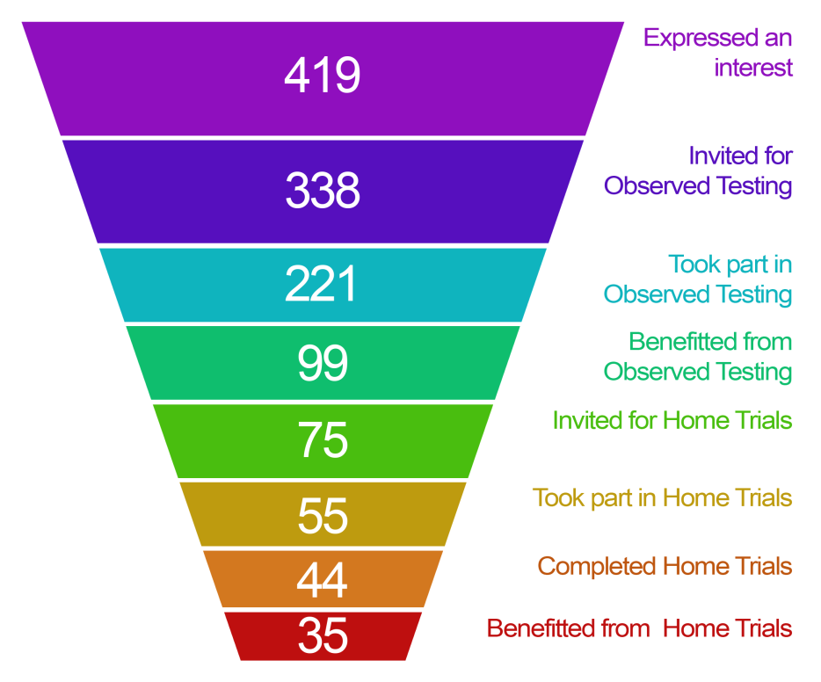

1.4 Overall conclusions

1.4.1 Indicators of benefit
Due to the design of the Smart Glasses display being a small rectangle within the central point of the visual field, we expected people with some remaining central vision to get more benefit than those with only peripheral vision. We did find a marked difference between the number of people who benefitted with peripheral vision loss and those with central vision loss. However, as the visual field information was gathered through self-report it was not possible to determine more fine-tuned visual field properties that would predispose a participant to benefit from the glasses or not. The categories we used to determine field of vision (central vision loss, peripheral vision loss, loss in both and unknown) were far too 8 broad to allow us to draw conclusions as to why some people with central vision did not benefit from the glasses.

The user testing showed that people with many different sight loss conditions could potentially benefit from using the glasses. Of the participants who did benefit, RP was the most represented sight loss condition. Across all sight loss conditions, those that tend to have some residual central vision (RP, Optic Nerve Damage and Cataracts) contained more participants that benefitted from the Smart Glasses than did not benefit.

During the testing, we ranked the severity of people’s sight loss with a rating from Low to Very High. We found that people from each group benefitted from using the Smart Glasses, although, as could be expected, people from the ‘Very High’ category, who therefore had more useful sight, benefitted slightly less from the glasses. Many people do not know, or have accurate details of, their sight loss condition or visual field. It would have helped this study to have every participant take individual comprehensive clinical sight examination on the day of their observed testing session. This would have dramatically cut the number of people that could have completed testing, as there would be further restrictions on locations and the cost per participant would be higher.

Age was more of an indicator of benefit. A higher percentage of younger participants (aged 19-39) reported a subjective benefit when first using the glasses. However, more participants in the age range of 19-64 showed a measurable benefit. This could be as a result of the nature of the product. As it is a high technology device, younger people might be more inclined to both try and use the Smart Glasses.

The results also show that two people with similar characteristics, for example, age, gender, visual field, visual acuity or sight loss condition, may not have the same experience when using the Smart Glasses. However, considering the participants who showed measurable benefit from the glasses after the observed testing and 9 the take home trial, there are some common trends and characteristics within these groups. The profile of the typical participant who is most likely to benefit from the glasses is between the ages of 40 and 64, with RP, with any visual field profile except central sight loss, and a sight severity level of medium.

1.4.2 Other factors impacting acceptability of the glasses
As we know that people with the same sight loss condition, sight loss, visual field or visual acuity might not experience the same benefit from the Smart Glasses, we cannot give clear guidance to narrow down those who are interested in using the glasses. When introducing the glasses to test participants, the glasses could not be used without a familiarisation session, conducted by a trained assessor, where the controls and usage of the glasses were explained. This version of the glasses should be seen more as a prescriptive solution for some people, rather than an off-the-shelf solution, and could be an addition to the Low Vision Assessment that is currently used to find the most suitable low vision aids.

Following the take home trials, many participants reported that being given the opportunity to take the glasses home with them and use them independently was very beneficial. Using the glasses gave participants an improvement in their quality of life and general confidence. For example, some reported that they felt more socially involved after wearing the Smart Glasses. One participant stated:
“The last few weeks have changed my social life completely. I have been out more than I have in the last few years. I can actually see people’s faces, in this way it is easier to talk to them and is definitely a rewarding experience.”

A number of participants felt that the glasses provided them with a feeling of safety, as they were aware of their surroundings and nearby dangers. Another participant stated that the glasses made him feel safe:
“I know there's a threat, and I know there's something there. Feels like I can control my own space.”

Some participants reported that even if they had a benefit using the Smart Glasses, this does not ensure that the glasses would always be useful to them in a real life environment. For example, within a familiar environment, participants reported having coping strategies in place already which nullify the benefit that using the Smart Glasses may have. Conversely, using the glasses in an unfamiliar environment brings other issues, such as safety, and a potential requirement for extra mobility training.

Similarly, the weight and bulk of the glasses were not too intrusive in the lab environment, but they were reported to be far less acceptable when used for longer periods of time, or when out and about.

As the benefit of using the glasses might not necessarily translate to usefulness outside of the testing environment, a loan period equalling or more than the period used in the take-home trials (three weeks) is recommended to show if the glasses are actually helpful and useful to a person in their daily life.

1.5 Recommendations
*As the Smart Glasses gave demonstrable benefit to people across all eye conditions, it is recommended that more work be carried out to bring these to market.

Methodology for further research:
- When measuring benefit, there should be a sliding scale, rather than only allowing answers of yes or no. For example, benefit could be measured on a scale of 1 to 5 to allow a better indication of the life changing benefit for the users. In this way it would be possible to better determine when the benefit does not outweigh the disadvantages of setting up, wearing and adjusting the glasses.
- A more detailed visual field assessment should be carried out for each participant so that more reliable indicators of sight loss are available.
- More useful feedback could be obtained from participants who are prepared to use the glasses over a longer period of time, to gauge how often the glasses are used after the initial “honeymoon” period.
- More accurate conclusions could be drawn by reducing the number of variables in the testing, for example focussing on just one mode or one sight loss condition.

Glasses physical design
- Both the glasses headset and control box should be made smaller and lighter if possible.
- The design of the dials on the control box should be reconsidered. A tactile pointer and a number of tactile marks around the dial could be introduced to assist people in identifying the dial’s current setting.
- There should be a clear indication on the control box showing which mode is selected.
- The design of the filter should prevent it falling out accidentally and the filter should be easy to fit.
- There should be clear audible and visual indications when the battery is running low.
- Any power switches (including the master power switch) need to be easy to use in order to conserve battery.
- A zoom function of better quality (for example if a HD camera is used) would be beneficial for clarity and magnification purpose. • A larger screen size (currently only 23 degrees, in the centre of the field of view) would be able to be used by people with more eye conditions. People with a good level of acuity in their peripheral vision would be able to see the screen.
- A larger screen size would also mean that those who can currently see the screen would have a larger field of view. The small field of view affects mobility and carrying out other tasks. Displaying an equivalent image to natural sight would be beneficial.

About RNIB’s research
RNIB is a leading source of information on sight loss and the issues affecting blind and partially sighted people. Our Research and Knowledge Hub contains key information and statistics about blind and partially sighted people including our Sight Loss Data Tool, which provides information about sight loss at a local level throughout the UK. You’ll also find research reports on a range of topics including employment, education, technology, accessibility and more. Visit our Knowledge and Research Hub at: rnib.org.uk/research

