Corneal dystrophies

The cornea
Your cornea is the clear part of the front of the eye. It is made up of a number of layers and is normally smooth and clear.

The cornea is very strong and acts as a barrier between your eye and the outside world, helping to protect it from injury and infection. The surface of the cornea is very sensitive. It contains many nerve endings and can detect even the smallest piece of dirt or fluff.

The cornea is important for sight, and it is important that it remains clear. It bends and focuses light into the eye. This light is then focused by the eye’s lens onto the retina, at the back of the eye. Your retina converts light into electrical signals. These are then sent to the brain where they are interpreted to “see” the world around you.

What is a corneal dystrophy?
Corneal dystrophies are a rare group of genetic conditions which cause changes to the cornea without any inflammation, infection, or other eye disease. Abnormal material accumulates in the cornea affecting the clarity (transparency) of your cornea. They usually involve both eyes.

Although corneal dystrophies often get worse over time, normally this happens very slowly. Many corneal dystrophies develop so slowly that they may never get to a point where they affect your vision.

Corneal dystrophies may not cause any symptoms. Sometimes affected individuals experience glare, pain or discomfort, light sensitivity, dry eye and in some cases a reduced level of vision.

What causes corneal dystrophies?
Corneal dystrophies often run in families, but this is not always the case. In some cases, it may not be possible to say why someone has developed their corneal dystrophy.

Corneal dystrophies can be passed down in your genes. Genes usually come in pairs. You inherit one gene from each of your parents to make each pair. When you have children, you only pass on one gene to them. There are two ways that corneal dystrophies can be inherited (passed on in families):

Autosomal dominant inheritance:
This means that one parent has the condition. Each time that parent has a child there is a 50 percent (one in two) chance of the child having the condition as well.

The diagram below shows the four possible ways in which a child can inherit the genes that relate to an autosomal dominant (AD) corneal dystrophy when either one of their parents has the condition. For each child these parents have, there is a 50% (two out of four) chance that they will inherit the condition, regardless of whether they are a boy or a girl. Equally, there is a 50% chance that each child will be unaffected.
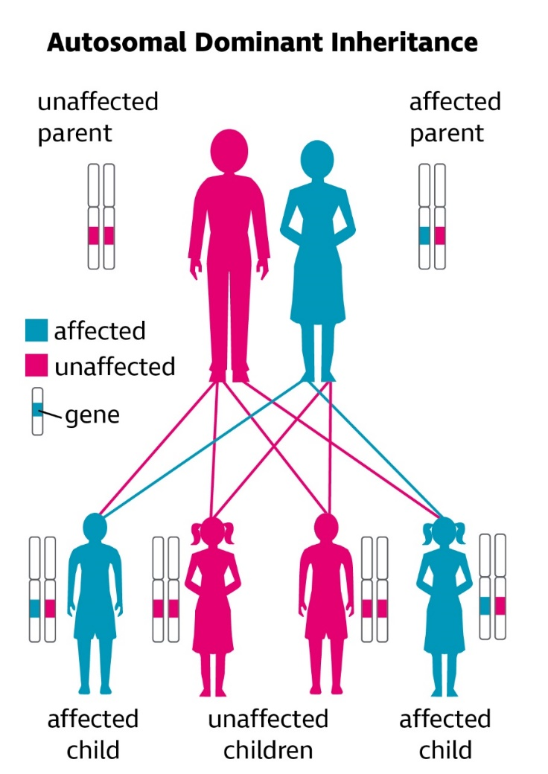

Autosomal recessive inheritance:
This means that neither parent has the condition themself, but both parents are ‘carriers’. If two carriers have children, there is a 25 per cent (one in four) chance that each child will have the condition. Both parents need to be carriers of the condition for their child to be affected.

The diagram below shows the four possible ways in which a child can inherit the genes that relate to an autosomal recessive (AR) corneal dystrophy when their parents are both carriers of the condition.

For each child these parents have:
- there is a 25% (one in four) chance that the child will inherit the condition, regardless of whether they are a boy or a girl
- there is a 50% (two out of four) chance that each child will be a carrier of the condition
- there is a 25% (one in four) chance that each child will inherit two completely normal genes.”

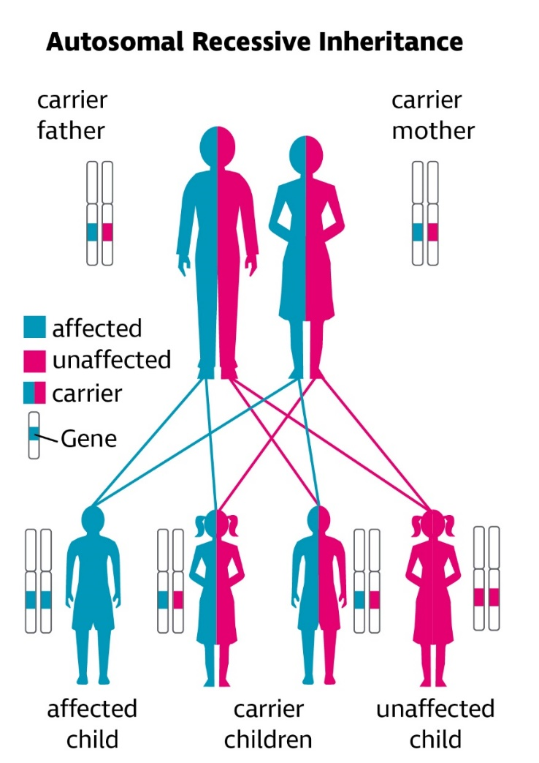

What types of corneal dystrophies are there?
The cornea is made up of five layers. Each layer has a different role in keeping the cornea healthy and clear. Corneal dystrophies can be described in many different ways, but because each dystrophy will start by affecting a particular layer of the cornea, they are often classified by layers of the cornea they affect.

The layers of the cornea from outer part of the eye inwards or front to back, and their function are:
- The corneal epithelium – Blocks the passage of foreign bodies, such as dust, water, and bacteria, into the eye and other layers of the cornea
- Bowman's layer – Helps in maintaining the shape of the cornea
- The corneal stroma – This is the thickest corneal layer, giving mechanical strength to the cornea and the cornea its transparency. Also, the main surface which bends light entering the eye through the cornea
- Descemet's membrane – Resting layer for endothelial cells
- The corneal endothelium – The endothelial layer acts as a pump, removing fluid from the stroma to keep it clear.

Diagram of cross section of eye (ciliary body, iris, cornea, anterior chamber, lens, vitreous) showing the different layers of the cornea as detailed above.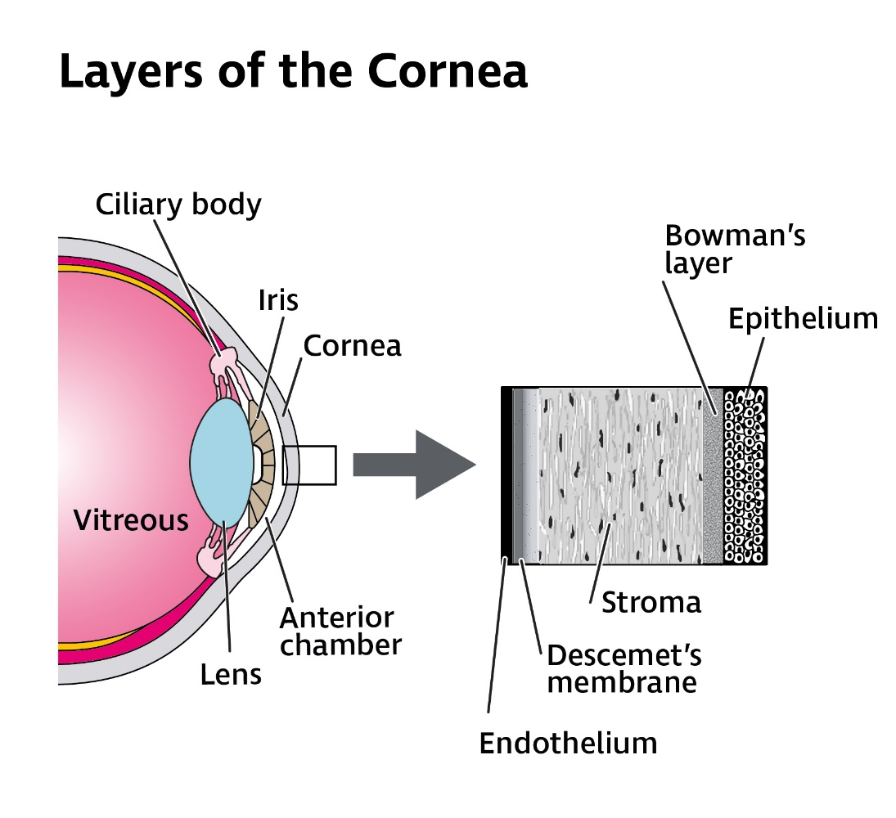

Epithelial dystrophies
The epithelium is the thin outermost layer of the cornea. It is a barrier protecting the rest of the cornea and the inside of the eye from foreign bodies, such as grit, and from infections. The epithelium is filled with tiny nerve endings that make the cornea very sensitive to touch. The epithelium also provides an extremely smooth surface, which is essential for good vision.

A common symptom of corneal dystrophies that affect the epithelium is a painful ‘foreign body’ sensation, which can feel like there is something in your eye. This can occur if there is a change in the cornea which disturbs the epithelium.

If the surface epithelial layer breaks down, the sensitive nerve endings become exposed causing a ‘foreign body’ sensation. This breakdown of the corneal surface is known as an ‘erosion’ and causes a similar feeling to when an eyelash or a piece of grit gets into the eye, but in some cases can be a lot more painful.

The epithelium can heal quickly so you may not experience these symptoms for very long. Treatment can also be given to relieve your symptoms and aid healing. Dystrophies that affect the epithelium include:

Epithelial basement membrane dystrophy (also known as map dot fingerprint dystrophy or Cogan’s dystrophy)
Epithelial basement membrane dystrophy is the most common epithelial dystrophy. It doesn’t usually run in families. However, very rarely, it is passed on in a family by dominant inheritance.

Most people have no symptoms but about 10 percent of people who have this dystrophy, go on to develop recurrent corneal erosions. As well as symptoms of ‘foreign body’ sensation, recurrent corneal erosions can cause pain, light sensitivity, blurred vision, redness and watering and you may not be able to open the affected eye. Corneal erosion pain may start suddenly, often when you first wake in the morning and get better later in the day. Most people who have these symptoms are over 30 years of age.

Erosions occur because this dystrophy changes the ‘basement’ or anchoring layer of the epithelium, which can cause small areas of the epithelium of the cornea to become detached. When an optometrist (optician) or ophthalmologist (hospital eye doctor) examines your cornea, these erosions can look like areas of land on a map, dots or fingerprints. This is the why this dystrophy is also known as map dot fingerprint dystrophy.

Although corneal erosions can be painful, they normally heal very quickly, sometimes within hours of the erosion happening. If you have corneal erosion, then you will usually have treatment to relieve pain and allow the cornea to heal.

The treatment you will be given will depend on how bad the erosion is and whether you have had many erosions before. If you need treatment, this will usually be eye drops to dilate (enlarge) your pupil. These drops will blur your vision but help to reduce pain by keeping the movement of your iris and ciliary body muscles inside of the eye to a minimum by paralysing these muscles, while your cornea heals.

Antibiotic eye drops can be added during acute flare-ups, to help prevent infection, as well as lubricating eye drops, gels or ointments to make your eyes feel more comfortable and prevent the inside of your eyelids sticking to or damaging the epithelium.

Typically, corneal erosions can flare up from time-to-time and settle again without causing any long-term problems with your sight. If you have very frequent severe erosions, other treatments may be needed to allow your cornea to heal, such as specialised ‘bandage’ contact lenses which are worn long-term to keep the eye comfortable, or ‘debridement’ where loose tissue is removed from the surface of your cornea. Debridement can be carried out manually, using blunt instruments or be automated, using lasers (excimer) to remove damaged tissue. Debridement can provide improvement in clarity of vision as well as comfort of the eye in some people.

Most people with this type of corneal dystrophy do not have sight problems and everyday activities such as driving or reading are not typically affected in the long term. It is very rare for someone with an epithelial basement membrane dystrophy to need a corneal transplant.

Meesman’s dystrophy
This is a very rare corneal dystrophy and is passed on in a family by dominant inheritance. This condition causes tiny round pockets of fluid, known as microcysts to form in the epithelial layer of your cornea. These develop early in life, sometimes within the first year and can increase in number over time. Meesman’s dystrophy usually affects both eyes.

The microcysts do not normally cause any symptoms until late adolescence or adulthood, when they can start to break open (rupture) on the surface of the cornea and cause discomfort. These changes may make you light sensitive, cause your eyes to water and feel like you have something in your eye. Some people may experience temporary episodes of blurred vision. This dystrophy may also make it difficult to wear contact lenses.

Meesman’s dystrophy is usually treated with eye drops to lubricate the front of the eye to help reduce symptoms and make your eyes more comfortable. Although people can have temporary flare-ups when microcysts rupture, Meesman’s dystrophy does not worsen over time so other treatments are not normally required.

Stromal dystrophies
The stroma is the middle layer of the cornea. It makes up around 90 percent of your cornea’s thickness. The stroma is made up of water and a material called collagen, which is arranged in regular fibres. This regular arrangement of collagen fibres means that the stroma is clear and very tough and elastic.

Stromal dystrophies cause deposits to build up in this layer. These deposits make your stroma less clear, affecting vision. Changes in your stroma can also affect other layers of your cornea causing corneal erosions to develop.

Reis-Bücklers dystrophy
Reis-Bücklers dystrophy is a very rare condition that often starts in childhood around the age of 4 or 5 or in early adulthood. Reis-Bucklers dystrophy is thought to have the dominant pattern of inheritance.

Reis-Bücklers dystrophy affects Bowman’s layer of the cornea. Bowman’s layer is the top layer of the stroma, separating it from the epithelium. In this dystrophy the tissue that makes up Bowman’s layer and the basement layer of the epithelium changes, resulting in irregularly shaped opacities in the stroma, causing painful erosions to develop.

Over time, although the erosions may settle down, the surface of the cornea can become hazier, affecting sight.

Reis Buckler dystrophy affects both eyes equally. The changes it causes tend to be in the middle of the cornea, so they are more likely to affect your vision. Reis-Bucklers corneal dystrophy can also cause a loss of sensation (feeling) to the surface of your cornea, which could mean you may not be aware if something goes in your eye, or if your cornea has been damaged. This could lead to further damage.

Treatments for Reis-Bucklers corneal dystrophy can include removing scar tissue from the surface of your cornea (epithelial debridement) or laser eye surgery to remove the cloudy area of the cornea.

If Reis-Bucklers dystrophy causes very poor vision, a corneal transplant may be needed. The most likely type of corneal transplant is a deep anterior lamellar keratoplasty (DALK). This transplant replaces the affected top layers of the cornea with the healthy top layers of a cornea from a deceased donor.

Very rarely, someone might need a penetrating keratoplasty (PK) corneal transplant. This is where your whole cornea is replaced with a new cornea from a deceased donor. Unfortunately, it is possible for Reis-Bucklers dystrophy to reoccur in the transplanted cornea, even if the transplant is successful. For this reason, a transplant might be delayed until sight is severely affected.

You can find more information about corneal transplant on our website rnib.org.uk/eyehealth or by calling our Helpline 0303 123 9999

Lattice dystrophy
Lattice dystrophy is the most common dystrophy affecting the stroma. It is passed on in a family by dominant inheritance and usually begins before the age of 20 years. Early symptoms tend to be a ‘foreign body’ sensation, which can feel like there is something in your eye and a slight change in vision. Some people may experience painful corneal erosions, but others have no symptoms.

Lattice dystrophy causes material to build up on the cornea in a lattice (grid) pattern. When your eye is examined under a microscope, called a slit lamp, very fine glassy-looking overlapping lines and dots can be seen in your cornea looking like ‘cracked glass’. As the dystrophy progresses, these lines become thicker and may make the cornea hazy, affecting your sight.

If you have a ‘foreign body’ sensation and erosions then you will be given treatment for these, which might include lubricating eye drops and/or antibiotic eye drops. If you experience serious sight loss, laser treatment, a deep anterior lamellar keratoplasty (DALK) or penetrating keratoplasty (PK) corneal transplant might be required.

Most people don’t need a corneal transplant before the age of 40.
The results of corneal transplant for lattice dystrophy are generally good, but it is possible for the dystrophy to recur in the donor cornea within two to 14 years.

Granular dystrophy
This dystrophy affects both eyes and is passed on in a family by dominant inheritance. Changes to your cornea usually begins before the age of 20. In the early stages, vision isn’t affected but when your eyes are examined using a slit lamp, small white deposits, which look like crumbs, sugar granules, rings or snowflakes can be seen in your cornea.

Slowly, over time these deposits increase in number and join together becoming larger and noticeable without a slit lamp.

Vision is not usually severely affected under the age of 50, but as the dystrophy worsens you may experience frequent painful recurrent erosions and glare and light sensitivity because of the increase in deposits.

If you develop erosions and your eyes are painful or uncomfortable, lubricating eye drops can be given to help soothe your eyes and allow the cornea to heal.

If the erosions are very frequent and not helped with drops, you may need laser treatment to remove some of the deposits and smooth the surface of the cornea to try to prevent or lessen these. Your cornea may also become less sensitive to touch and pain due to the dystrophy. This can mean that you may not be aware that you are developing erosions or that your cornea is damaged. Painful recurrent erosions can increase the haziness of the stroma and this can lead to further reduced vision. If you experience serious sight loss due to granular dystrophy, a deep anterior lamellar keratoplasty (DALK) or penetrating keratoplasty (PK) corneal transplant may be required.

Corneal transplants are successful in treating this dystrophy, although granular dystrophy can recur in the transplanted cornea. If this does happen it tends to be mild and can be treated with laser if it is causing a problem.

Macular corneal dystrophy
This dystrophy is passed on in a family by recessive inheritance, which makes it less common, but more severe, than other stromal dystrophies.

Macular corneal dystrophy causes dense greyish-white deposits to form in the stroma. With time, more and more of these deposits develop, eventually causing the whole stroma to become cloudy.

These changes also cause the cornea to become thinner and irregular in shape. As well as reducing vision, macular corneal dystrophy can also make someone sensitive to light and cause painful erosions to develop.

Often between the ages of 20 to 40 there will be serious sight loss due to this dystrophy. You may need either a deep anterior lamellar keratoplasty (DALK) or penetrating keratoplasty (PK) corneal transplant.

A corneal transplant gives a good outcome for people with macular corneal dystrophy. Although it is possible for macular corneal dystrophy to return in the transplanted cornea, it is less likely for this dystrophy to return than with other stromal dystrophies.

Endothelial dystrophies
The endothelium is an extremely thin single layer of cells, which makes up the innermost layer of your cornea. This layer is vital for keeping the cornea clear, as it acts as a pump controlling the movement of fluids and nutrients in and out of your cornea.

Without this pump, the cornea can swell with fluid and become hazy. This layer cannot repair itself, so conditions that affect the endothelium can cause swelling of the cornea that can lead to serious sight loss.

Fuchs endothelial dystrophy
Fuchs corneal endothelial dystrophy is passed on in a family by dominant inheritance. As a normal part of getting older, a small number of endothelial cells are lost. This does not normally cause any changes in vision. In Fuchs dystrophy, this process speeds up and more cells than usual are lost.

Eventually, enough cells are lost that the endothelium doesn’t work well enough to prevent fluid soaking into the cornea or as a pump to remove it. This causes the cornea to swell due to the build-up of fluid, known medically as ‘oedema’. This oedema can affect vision.

Fortunately, Fuchs dystrophy develops slowly. It is normally detected when someone is in their fifties or sixties. Not everyone who is diagnosed with it experiences problems with their vision. As it develops, it can cause sensitivity to light and can make your vision cloudy.

If the changes to your sight are starting to cause you difficulties, your ophthalmologist may recommend that you have a corneal transplant, often an endothelial keratoplasty (EK) transplant, which selectively removes and replaces the innermost layers of the cornea with tissue from a deceased donor.

Corneal transplants are extremely successful in treating Fuchs dystrophy.

You can find more information about Fuchs dystrophy on our website rnib.org.uk/eyehealth or by calling our Helpline 0303 123 9999

How can I manage with the symptoms of corneal dystrophy?
Corneal dystrophies can often cause typical symptoms of glare, pain or discomfort, light sensitivity, or dry eye. Some different ways of coping with these symptoms are listed below.
- If you develop erosions and your eyes are painful or uncomfortable artificial tear (lubricating) drops help soothe your eyes and allow the cornea to heal.
- Use of lubricating gel or ointment last thing at night helps to prevent the inside of your eyelids sticking to or damaging the epithelium and make it easier to open your eyes first thing in the morning.
- As you are likely to need these lubricating preparations longer term, it’s useful to ask for ‘preservative free’ drops, as this helps to make your eyes feel more comfortable.
- On awakening in the morning, move your eyes and lids slowly when opening your eyes for the first time to avoid any sudden friction to the epithelial surface creating a recurrent erosion.
- Wearing sunglasses can help minimise any discomfort you experience from glare and light sensitivity. You may need a different colour and depth of tint for indoors and outdoors. Tints needed for indoor use tend to be lighter than tints for outdoor use.
- Turning down the brightness of your computer screen can help with glare and light sensitivity.

You can find out more about coping with light sensitivity and dry eye on our website rnib.org.uk/eyehealth or by calling our Helpline 0303 123 9999

Can I get help to see things better?
If your corneal dystrophy has caused reduced vision, then there is much that can be done to help you make the most of your remaining vision and adapt to any changes.

This may mean making things bigger, using brighter lighting or using colour to make things easier to see. We have a series of leaflets with helpful information on living with sight loss, including how to make the most of your sight. You can find out more about our range of titles by calling our Helpline on 0303 123 9999.

You should ask your ophthalmologist, optometrist or GP about low vision aids and having a low vision assessment. During this assessment you’ll be able to discuss the use of magnifiers and aids to see things more clearly.

Local social services should also be able to offer you information on being safe in your home and getting out and about safely. They should also be able to offer you some practical mobility training to give you more confidence when you are out.

Our Helpline can also give you information about the low vision services available, support with education and employment, and our website offers lots of practical information about adapting to changes in your vision and products that make everyday tasks easier.

Coping
It’s completely natural to be upset when you have been diagnosed with a corneal dystrophy and it’s normal to find yourself worrying about the future and how you will manage with any changes in your vision.

It can sometimes be helpful to talk over some of these feelings with someone outside your circle of friends or family. At RNIB, we can help with our telephone Helpline and our Counselling and Wellbeing Team. You may also find your GP or social worker can help you find a counsellor if you feel this might help you.

Your eye clinic may also have an ECLO (Eye Clinic Liaison Officer) who can be on hand to provide you with further practical and emotional support about your eye condition.

Further help and support
Whether you have just been diagnosed or have been living with sight loss for a while, we are here to help and support you through your journey.

The RNIB Helpline is your direct line to the support, advice and products you need. We’ll help you to find out what’s available in your area and beyond, both from RNIB and other organisations.

Whether you want to know more about your eye condition, buy a product from our shop, join our library, find out about possible benefit entitlements, be put in touch with a trained counsellor, or make a general enquiry, we’re only a call away.

RNIB Helpline
Tel: 0303 123 9999
Email: helpline@rnib.org.uk
Alexa: you can also say, “Alexa, call RNIB Helpline” to an Alexa-enabled device.
We’re ready to answer your call Monday to Friday 8am to 8pm and Saturday 9.30am to 1pm.

You can also get in touch by post or by visiting our website:

RNIB
105 Judd Street
London WC1H 9NE
rnib.org.uk

We value your feedback
You can help us improve our information by letting us know what you think about it. Is this factsheet useful, easy to read and detailed enough – or could we improve it?

Send your comments to us by emailing us at eyehealth@rnib.org.uk or by writing to:

Eye Health Information Service
RNIB
105 Judd Street
London
WC1H 9NE

This factsheet has been written by the RNIB Eye Health Information service. Our factsheets have been produced with the assistance of patient and carer input and up-to-date reliable sources of evidence. The accuracy of medical information has been checked by medical specialists. If you would like a list of references for any of our factsheets, please contact us at eyehealth@rnib.org.uk

All our factsheets are available in a range of formats including print, audio and braille.

This factsheet has been produced jointly by RNIB and The Royal College of Ophthalmologists.

RNIB is a member of the Patient Information Forum (PIF) and have been certified under the PIF TICK quality mark scheme.

Last updated: March 2022
Next review: March 2025

End of document.

