Learning braille – courses and resources for children and young people

There are several ways in which children and young people can learn to read braille. In this factsheet we explain about the different types of braille, provide information on the courses available for teaching children to read and write braille, and highlight useful products and publications available to purchase from RNIB.

If you would like to order any items mentioned, or request a copy of our Braille and Mobility or Everyday Living catalogues, either visit www.rnib.org.uk/shop or telephone our Helpline on 0303 123 9999. To make browsing and ordering easier, RNIB product codes are listed in brackets.

Contents
Learning braille 4
Uncontracted and contracted braille 4
Unified English Braille (UEB) 5
What are the main differences? 5
Braille courses 6
Feeling Ready to Read 6
Hands On 6
Take Off 7
Abi books 7
Products for teaching and learning braille 7
Shared reading books 7
Sense and Sensitivity by Nigel Berry 8
Tactile Alphabet and Numbers Sheets 8
Braille Dots Tactile Reward Stickers 8
Braille Teaching Cube Keyring 9
Braille Alphabet Card 9
Everyday living solutions product catalogue 9
Welsh braille 9
Braille music 10
Literacy assessment 10
Neale Analysis of Reading Ability 10
Learning Media Assessment 11
Rules and reference books 11
Rules of Unified English Braille 11
Guidelines For Technical Material 11
Using the braille code series 11
Introduction to braille for sighted readers 12
Braille alphabet card 12
Everyday braille 12
Crack the code 12
A Braille Reader in the Family 13
The braille trail activity sheets 13
Buying and borrowing books 13
Shared reading books 13
Magazines 13
National Library Service 14
ClearVision Library 14
Products to read and write braille 14
Perkins brailler 15
Braille translation software 16
Electronic braille displays 17
Braille writing frames 17
Braille paper 18
Braille labelling 18
Everyday living solutions product catalogue 18
Product grants 19

Learning braille
Children who are learning to read and write braille will benefit from developing pre-braille skills first and this factsheet lists courses available for teaching braille to children. Most of the materials are aimed at young children learning to read through braille and offer a phonetic introduction and systematic progression through the complete contracted braille code, with supplementary material at various stages. There is also a comprehensive course for older children transferring to braille, who need to learn a new way of reading rather than how to read.

It can help beginner touch readers to read materials in double line spacing at first, so they can track lines more easily. Sighted people generally read braille by sight, so need reading materials with braille on just one side of the paper (single-sided).

Please call our Helpline on 0303 123 9999 if you need any further help with getting started with braille.

Uncontracted and contracted braille
Uncontracted braille (formerly known as Grade 1) is a letter-for-letter translation from print. It includes the alphabet, numbers, punctuation marks, representation of print symbols and composition signs. Anyone who is familiar with uncontracted braille can quite easily go on to learn the additional signs for contracted braille at a later date if desired. Uncontracted braille is quicker to learn but takes up more space. Many books and magazines are available in uncontracted braille, as well as bank statements and labels on medicines and lift buttons. Anyone who knows uncontracted braille can label items and enjoy card and other games with friends.

Contracted braille (formerly known as Grade 2) is a more complex code, which includes a number of extra signs and some shorthand in addition to the characters in uncontracted braille. Commonly occurring groups of letters are represented by one or two signs – for example, ING, THE, ST and EN are single characters, while TION, ENCE and OUND are represented by two characters.

Contracted braille also includes a kind of shorthand, where groups of letters represent complete words – for example, AFN is afternoon, QK is quick and FR is friend. Contracted braille takes considerably longer to learn, but there is a larger range of material available in this format, and contracted braille takes up about 12 per cent less space than uncontracted.

Unified English Braille (UEB)
Unified English Braille was developed by the International Council on English Braille (ICEB), to bring together several existing braille codes. This means that rather than the old codes for Maths, Sciences and literary material there is just one code. In October 2011 UEB was adopted in the United Kingdom and in 2013 the updating of braille courses began. The UK is not alone in adopting UEB and joins other countries such as New Zealand, Australia, South Africa, Nigeria, Canada and the USA. Many ambiguities which existed in Standard English Braille (SEB) no longer exist, making it easier for braille learners.

All our braille courses are UEB, we no longer offer SEB courses.

What are the main differences?
With regards to the literary code there are very few differences. The main changes affect the technical material; however, the key differences are listed below:

- The removal of sequencing (you cannot write 'and', 'for', 'of', 'the', 'with', 'a', un-spaced from one another).
- Nine contractions, are no longer used ('ble', 'com', 'dd', 'ally', 'ation', 'to', 'into', 'by') and the shortform 'o'clock'.
- The potential inclusion of type form indicators (for example, font changes, bold and underlining have been introduced).
- The revision of some punctuation signs (for example, there are now different symbols for open brackets, close brackets, the ellipsis and dash).
- There are braille signs for more print symbols, for example, up and down arrows, tilde, backslash, underscore; and shapes, for example, square and circle.

The changes made to UEB – to reduce ambiguities and to incorporate literary and technical braille into a single code – do mean that UEB takes up slightly more space than SEB. This increase is minimal for literary materials (around two per cent, or five and a half per cent if you include the effect of capitals), and more for technical materials. More specifically:

- The reason sequencing has been removed is because the rules of UEB symbol construction require that where there is blank space between words in print, there should be a blank space in braille.
- The nine contractions ('ble', 'com', 'dd', 'ally', 'ation', 'o'clock', 'to', 'into' and 'by') have mostly been dropped because each sign should have one unambiguous meaning, for example, 'ble' is already used as the numeric indicator (formerly the number sign), 'com' is used as the hyphen and 'ation' is capital n etc.
- Type form indicators (for example, font changes and bold) can now be represented in braille, to take account of the fact that braille users may find themselves working in a print environment where it is important to know the format of the printed text. Braille producers should however take care to include these indicators only where they are relevant.
- Some punctuation signs now take up two cells whereas previously they only took one. This is to remove ambiguity, for example, in the case of brackets there is now a different symbol for open and close square brackets.

Braille courses

Feeling Ready to Read
Feeling Ready to Read is a pre-braille skills course based on the story of Snow White and the Seven Dwarves. It is available to download from Bookshare, and includes all of the PDF files which make up the different booklets, as well as the teachers’ guide in braille and print.

Hands On
Hands On (TC21403) is a first stage braille reading scheme, designed for a young child, which introduces the alphabet and alphabetic word signs, strong contractions, a few short forms, numbers 1 to 10, basic punctuation and capitals.

Hands On does not introduce the full contracted braille code, see Take Off (below) for the second stage scheme.

Divided into five levels, Hands On includes 32 practice books, a booklet of fun activities and several real stories at each level. The whole scheme includes simple tactile pictures and puzzles to enliven the reading material. It is linked as closely as possible with the Letters and Sounds framework, while not compromising the need to keep tactually confusing braille signs apart.

Take Off
Take Off (TC21413) is a second stage scheme for young learners to develop phonic skills, knowledge of braille contractions and word signs, as well as encouraging enjoyment of reading and writing. The course takes the learner who has completed 'Hands On' or 'Braille for Infants' (available to purchase in UEB from Childvision in Ireland) to the end of the contracted braille code and has been produced in consultation with the VIEW Children's Braille Committee.

Each series is identified by a raised domino and tactile illustration on its coloured cover. A print version of the capitalised braille text appears on facing pages throughout to encourage shared reading at home and school. Each booklet contains a practice page and story; booklets in series 1 to 10 also include a “fun page” of activities to encourage braille writing.

Abi books
These humorous stories (TC21432) feature the adventures of a sparky young blind girl with tactile pictures on the covers to appeal to young readers who have completed 'Hands On' or 'Braille for Infants' (no longer available). They introduce additional braille signs and a print version of the text appears on facing pages to encourage shared reading between sighted and touch readers. Capitalised braille is used throughout.

Products for teaching and learning braille

Shared reading books
These picture books for young children are adapted to include UEB on either interleaved clear sheets or clear self-adhesive labels, allowing the print text and images to be seen underneath and the book to be shared and enjoyed by everyone.

Our selection of delightful print and braille books includes touch-and-feel books for pre-schoolers as well as story books and non-fiction titles for primary children.

Sense and Sensitivity by Nigel Berry
This practitioner's guide focuses on how to teach braille reading and writing to adults and young people who are losing or have lost their sight.

It provides a structure for introducing braille to new touch readers, guidance on establishing good reading and writing techniques and selecting appropriate resources.

The book includes unique insights into the development of shape and pattern perception through touch.

Nigel Berry, a true champion of braille, sets out the benefits of using braille at home, for study and in the workplace as part of a comprehensive communication package that enables blind people to regain maximum independence.

Sense and Sensitivity is available from RNIB Bookshare in Word, PDF and braille (SEB only).

Tactile Alphabet and Numbers Sheets
Help your little one learn their alphabet and count to 10 with these tactile print and braille alphabet and number sheets (LB30). A perfect introduction for pre-schoolers.

Braille Dots Tactile Reward Stickers
Braille Dots Tactile Reward Stickers (ET37) allow blind and partially sighted young people to be rewarded with a sticker, like their sighted friends. Embossed, fun, colourful designs, these stickers encourage tactile exploration while building confidence.

These stickers with tactile, raised animal graphics and sport phrases in braille and in print, are fun for all. With their unique designs, these bright images provide tactile, visual and cognitive stimulation; whilst also strengthening sensory and literacy skills.

Each pack includes 12 stickers, each a unique design; printed and embossed on two A5 sheets (14.9 × 21cm). Stickers are 5.2cm in diameter and use uncontracted UEB.

Also available: Sports theme (ET38), Spanish theme (ET39).

Braille Teaching Cube Keyring
Whether you’re learning braille for yourself, or to support someone else, this braille keyring (LB29) is a fun way to start. The yellow cuboid is made up of three rotating blocks with raised black dots and indented dots for the blank part of the six-dot braille cell. Swivel any of the blocks to form a braille character. An internal pivot mechanism enables each block to turn independently, allowing the creation of every possible character.

The cuboid has a practical and sturdy metal key chain attached. Our free tactile Braille alphabet card (PR10223) is an ideal resource to pair with this product.

Braille Alphabet Card
This simple card (PR10223) showing the letters of the alphabet in both print and embossed dots can be used by sighted and touch readers alike to learn the braille alphabet. Some basic punctuation signs and numbers are also shown.

Everyday living solutions product catalogue
Our product catalogue contains our newest products, our bestsellers and a wide selection of our popular and essential everyday items.
The catalogue is available to order in three formats: Large 16-point print (IP413P), Contracted Unified English Braille (IP413B), DAISY audio CD (IP413CD).

You can also download the product catalogue from the online shop.

Welsh braille
Blind and partially sighted children can learn to read and write Welsh braille, using the Welsh Braille Code. The programme "Dechrau Darllen Braille Cymraeg" (Starting to Read Welsh braille) consists of 40 graded books. There is also a library of Welsh books in braille and a catalogue is available on request. To find out more about Welsh braille, the books available and training options, call RNIB Cymru on 029 2082 8500 or email CardiffTranscription@rnib.org.uk

Braille music
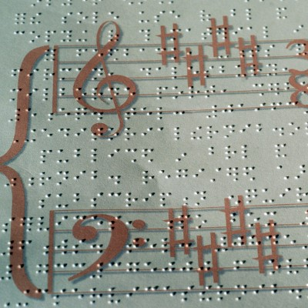
RNIB's Music Advisory Service (MAS) supports people with sight loss in any aspect of making music through individual advice and support, as well as their friends, family members and professionals. Whatever your musical interest, ability or experience. Contact us on 0303 123 9999 or email mas@rnib.org.uk

The following publications support learning braille music notation:

- Braille Music for Beginners – Piano by Joan Partridge.
Large print for sale from RNIB (25282903)
Contracted braille for sale from RNIB (25282902)

- A Guide to Braille Music Notation by Edward Watson
Large print for sale from RNIB (TC20278)
Contracted braille for sale from RNIB (TC20279)

- Focus on Braille Music by Lisette Wesseling
Large print and contracted braille for loan from RNIB Library.
Large print and contracted braille for sale from New Zealand for the Blind. You can email them at GeneralEnquiries@BlindFoundation.org.nz or visit their website blindfoundation.org.nz

Literacy assessment

Neale Analysis of Reading Ability
The Neale Analysis of Reading Ability (NARA) measures accuracy, rate of reading and comprehension in children aged five to 18 reading contracted braille.

The test (in capitalised and uncapitalised braille) can help to plan teaching programmes, ensure that reading materials match children's ability, diagnose needs so that appropriate action can be taken, check specific skills have been acquired and probe children's interest in reading.

NARA is now available to download from RNIB Bookshare (UEB only) https://www.rnibbookshare.org/cms/nara

Learning Media Assessment
A guide to help assess, evaluate and put in place appropriate teaching methods and literacy formats to support children in their literacy development, written by Cay Holbrook. It is available in print or braille from Texas School for the Blind and Visually Impaired (TSBVI).

Rules and reference books
The Paperback Oxford Large Print Dictionary is intended as a conveniently-sized and clear large print dictionary and contains Usage Notes to help you deal with potentially sensitive and offensive terms. It is available from several online sellers.

Rules of Unified English Braille
Rules of Unified English Braille (TC21419P, TC21419B) is the definitive reference book for UEB; it includes everything from the alphabet and basic punctuation to the rules for contracted braille, symbols and accented letters, as well as an appendix listing all the UEB signs. Please note, this is a reference book and not suitable for learning braille.

Guidelines For Technical Material
Guidelines For Technical Material (TC21425P, TC21425B) builds on the information in the Rules of Unified English Braille, giving more detailed information and examples of how to transcribe technical material such as maths and science.
It is also available to download from the International Council on English Braille website.

Using the braille code series
Guides for use by educational professionals to teach pupils using braille as their main medium for communication. Written by the RNIB/VIEW Curriculum Groups in 2007/8, they were revised and updated following the adoption of Unified English Braille (UEB). Available in braille and print from our online shop.

Using UEB for Mathematics is a guide to representing mathematics in UEB. Covering topics such as numbers and arithmetic signs, superscripts and subscripts, square roots, fractions and decimals, unit abbreviations, date and time, algebra, trigonometry and geometry, Greek letters, vectors and matrices; this book is a practical guide for those wanting to show maths in UEB. The book also includes appendices giving examples of set-out arithmetic calculations, a list of symbols and details on the use of the grade 1 indicator. Available in braille (TC21446) and print (TC21445).

Using UEB for Science contains examples of most of the common units of measurement and chemical symbols found in the Key Stage 3, Key stage 4, and Advanced level curricula. The examples are not meant to be exhaustive but should act as a guide to solving the common problems which occur when transcribing science notation into Unified English Braille. Major topics covered in this book are numbers and maths, unit abbreviations, chemistry, physics (including circuit diagrams) and genetics. Available in braille (TC21449) and print (TC21448).

Introduction to braille for sighted readers

Braille alphabet card
The Braille alphabet card (PR10223) shows the embossed braille alphabet, punctuation marks and numbers, together with the print translation.
It is also available in Welsh (TC20802) – please call our Helpline on 0303 123 9999 to place your order.

Everyday braille
Everyday braille offers an introduction to braille for sighted friends and family. It explains the braille code and how useful even a little braille can be in making a difference to the life of a blind or partially sighted person. The leaflet also covers braille production methods, daily uses and includes some reading exercises. It is available in print (TC20401) – please call our Helpline on 0303 123 9999 to place your order.

Crack the code
Crack the code is full of activities, puzzles and jokes and is designed to introduce the uncontracted braille (grade 1) alphabet, simple punctuation and numbers. It should not take more than a couple of hours to complete. You can download it for free from ClearVision Library.

A Braille Reader in the Family
This booklet for parents contains information about braille and tips on how to help a child who is or who will be learning braille. The activities and games have been suggested by teachers and parents, and most do not require knowledge of braille – although parents are encouraged to learn the alphabet. Many children will be the only person they know learning braille, so the booklet also includes positive quotes from braille readers of all ages. You can download it for free from ClearVision Library.

The braille trail activity sheets
Based on the book by Frances Mary D'Andrea and Anna Swenson, these free activity sheets offer students, parents, and teachers, a delightful and fascinating introduction to braille. Designed to teach sighted children about braille and encourage literacy among all children by using games, graphics and activities. You can download the free PDF from the American Printing House for the Blind.

Buying and borrowing books

Shared reading books
Shared reading books are standard print books that have been adapted to include braille on clear interleaved sheets or on clear labels which have been stuck to the pages of the book. This allows the pictures and print story to be read underneath, enabling shared reading between sighted and blind readers, such as parent and child, teacher and child, friends. They are available while stocks last from our online shop.

Magazines
RNIB publish a range of braille magazines for children and young people.
- Blast Off! is for children aged seven to 11, and contains factual articles, stories, recipes, jokes and puzzles; available in uncontracted or contracted braille
- Missy is aimed at young teenage girls. The magazines contain pop gossip, problem pages, interviews, sports news and real-life stories; available in contracted braille.

For a full list of magazines available, call our Helpline on 0303 123 9999, email helpline@rnib.org.uk or read our online factsheet.

National Library Service
The RNIB Library Service has more than 10,000 titles in braille, giant print (24 point) and unabridged audio for children and young people. From contemporary novels to older favourites we have books by authors such as Stephenie Meyer, Roald Dahl, Jacqueline Wilson, and Michael Morpurgo to name just a few! We also stock non-fiction, and although we don't loan text books, many of our titles do indirectly support the Curriculum. Books can be sent to home or school.

You can browse the Library catalogue for titles that are available to borrow.

To join the Library or for information on buying braille books, please call our Helpline on 0303 123 9999 or email helpline@rnib.org.uk

ClearVision Library
ClearVision Library offers over 14,000 print picture books adapted to include braille or Moon on clear plastic sheets, so that pictures and text are not obscured. The books chosen are from popular fiction and non-fiction, and are mainly for pre-school and primary-aged children. They are designed for blind and partially sighted children, who are learning to read through braille or Moon, to share print books with their sighted families, classmates, teachers and friends. They are also useful for blind adults wanting to read with sighted children. For further information please contact the ClearVision Library on telephone 0208 789 9575 or by email info@clearvisionproject.org

Products to read and write braille
Braille can be manually written using a Perkins brailler or with a hand frame and stylus to write dot by dot. It can also be digitally produced using transcription software, conversion software built-in to devices and then read on an electronic braille display or printed on an embosser.
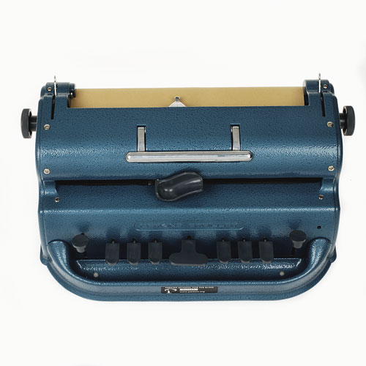

Perkins brailler
The braille typewriter has a key corresponding to each of the six dots of the braille cell, a space key, a backspace key, and a line space key. Like a manual typewriter, it has two side knobs to advance paper through the machine and a carriage return lever above the keys. Braille is produced on one side of the paper only and can be checked as it is being written.

The Perkins Classic brailler (BM36) is the most widely used mechanical braille writer in the world since its invention in 1951. Metal casing, closed body architecture (limiting dust accumulation), and over 66 years of craftsmanship, result in a resilient product. It can be used with wide paper to accommodate complex math, note taking or other literacy activities; producing up to 42 braille characters per line.

The Jumbo cell Perkins brailler (BM07) has all the same great features of the Perkins Classic brailler, but also has enlarged braille cells creating more space between dots to accommodate people with tactile challenges and find standard braille difficult to read. The cell is 40 per cent larger and the spacing between characters is 50 per cent wider. The braille dots themselves are not larger.

The Unimanual Perkins braille (BM08) has all the same great features of the Perkins Classic brailler but has been adapted for one-handed use. When the left-hand keys (dots 1, 2, 3) are pressed they remain depressed, until the spacebar or the right-hand keys (dots 4, 5, 6) are pressed.

The SMART brailler is an early learning tool designed to promote an interactive educational experience between learners, teachers and parents by displaying, vocalising, and brailling what a learner types. Weighs 20 per cent less than the Perkins brailler, making it easy to transport between home and classroom. You can edit, save and transfer documents from the braille to saved digital text files via USB.

The standard keys on a Perkins brailler may not be suitable for everyone and they can be replaced with Perkins curved extension keys (BM10) to suit people with limited dexterity or hand strength.

Braille translation software
Software can be installed onto a computer which then enables you to convert text from into electronic braille. One example of this software is Duxbury braille translation software (HT106) which can convert text into both uncontracted and contracted braille. The converted braille can then be printed out using a braille embosser.

Electronic braille displays
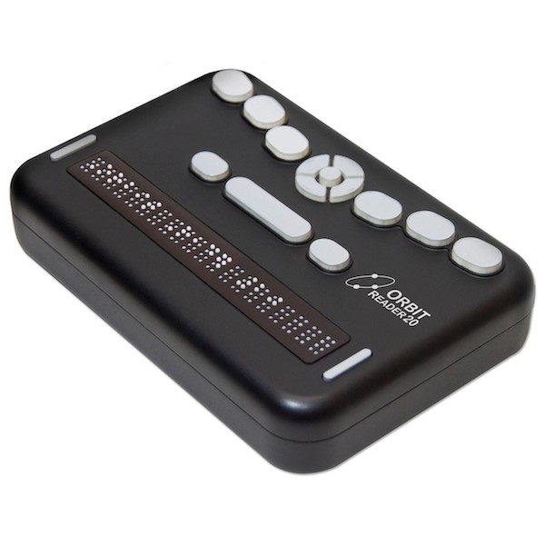
There are many electronic braille displays on the market which link to a computer and provide the on-screen information in braille, instantly. They are made up of a number of braille cells which refresh with a new line of braille as you read down the page.

Braille notetakers take things a step further and integrate a braille, display, braille keyboard and many features usually found on a computer into a standalone device.

The Orbit Reader 20 (HT358) is a compact and revolutionary refreshable braille display which offers easy book reading and note-taking at an affordable price. The Orbit Reader 20 is portable and features 20 refreshable eight-dot braille cells. It offers reading books via SD card, simple note-taking, Bluetooth and USB connectivity.

If you are registered blind or partially sighted, aged eight to 29, and a UK resident you could be eligible for a grant toward the cost of an Orbit Reader 20 – learn more about RNIB product grants from VICTA.

The Braille Sense U2 (HT247) is a portable 32-cell braille notetaker with native access to Excel and PowerPoint files, YouTube, Dropbox, Facebook, Record in DAISY and so much more.

Braille writing frames
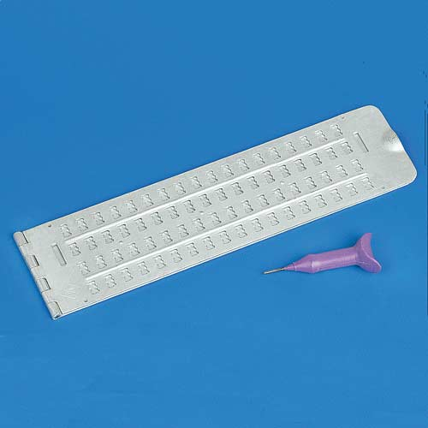
A braille frame and style (also known as slate and stylus) is to a braille reader what pen and paper is to a print reader. The frame and style are designed to emboss the braille characters onto paper, one dot at a time. The base of the guide has rows of recessed braille cells, whilst the top part of the frame has rectangular guidance windows the size of braille cells, these guide the style into the correct position to emboss the characters.

Like pen and paper, the frame and style are inexpensive, portable, and simple to use with many uses such as jotting down a phone number, making a shopping list, writing a note or adding a braille note to a document.
View our full range of braille frames and styles in the “Braille and labelling” section of our online shop.

Braille paper
Braille paper is available in a choice of sizes, weights and materials. It is suitable for use with our range of braillers and braille frames. Lightweight paper is suitable for most personal work. Heavyweight paper is suitable for creating braille documents that need to last a long time. Brailon is a plastic paper used primarily to reproduce tactile graphics and useful for people who struggle to feel braille dots on standard paper.

Braille labelling
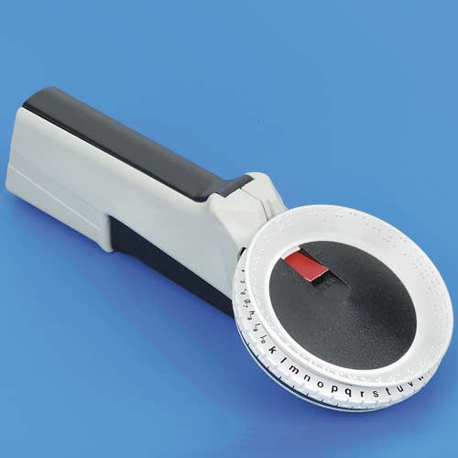
The easy to use, hand-held Braille labeller (DL65) can produce self-adhesive braille labels on braille labelling tape, without needing any knowledge of braille. It produces uncontracted braille and some contractions.

Braille labelling tape is used for producing self-adhesive braille labels and can be used with the Brailler labeller (DL65), a braille frame or a SMART Brailler that has a Labelling tape adaptor (BM43) fitted.

Clear self-adhesive sheets (DL11) are ideal for producing braille labels for items with a long life, such as DVD and CD collections or items where a sturdy label is required.

Browse the “Braille and Labelling” section of our online shop for more braille labelling products.

Everyday living solutions product catalogue
Our product catalogue contains our newest products, our bestsellers and a wide selection of our popular and essential everyday items.

The catalogue is available to order in three formats: Large 16-point print (IP413P), Contracted Unified English Braille (IP413B), DAISY audio CD (IP413CD).

You can also download the product catalogue from the online shop.

Product grants
The Orbit Reader 20 (HT358) is available to apply for through the RNIB Technology Grant Scheme. Other items include video magnifiers, kitchen equipment, clocks and watches, computer software, phones and DAISY players.

For further information on the terms and conditions and to download the Grant Application form please visit rnib.org.uk/grants or contact our Technology for Life Team on 0303 123 9999.

RNIB and VICTA are working together to support children and young people who are blind or partially sighted to study with greater independence using technology. If you are registered blind or partially sighted and a UK resident, you could be eligible for an iPad and/or and braille reader.

Apple iPad Air 2 (32GB) – available to those aged between 11 and 25 years
Orbit Reader 20 – available to those aged between 8 and 29 years.

Visit victa.org.uk/rnib-product-grant/ for more information or call VICTA on 01908 24 08 31.

Updated: January 2020

