Fuchs’ endothelial corneal dystrophy
Fuchs’ endothelial corneal dystrophy (FECD) is an eye condition that affects your cornea, the clear front “window” of your eye. The cornea is made up of different layers and it is the innermost layer called the endothelium which is affected by FECD. FECD may cause your cornea to become swollen, cloudy and sensitive to light, and your vision may decline as a result.

FECD is three to four times more common in women than men, usually affects both eyes and is typically seen in people in their 40s and 50s but it can also occur at a much earlier age or later in life.

FECD usually develops slowly and can affect people to a varying degree. While some people may never have any real problems with their vision, some may notice blurring and glare quite early on.

What is the cornea?
Your cornea is the clear dome shaped part of the front of your eye. It’s made up of layers and is normally smooth and transparent (clear). The cornea is very thin (approximately 0.5mm thick) but it is also very strong. The surface of the cornea is very sensitive. It contains many nerve endings and can detect even the smallest piece of dirt, fluff or eyelash which can cause irritation. This is a warning sign that something has gone into the eye. Your cornea acts as a barrier between your eye and the outside world, helping to protect your eye from injury and infection as well as from dust, germs and other harmful or irritating material.

A major role of your cornea is to bend and focus light as it enters your eye. If your cornea is not clear, it will not be able to focus light well and your vision will be affected. When light is focussed onto the retina at the back of your eye, it is converted into electrical signals that are sent to the brain through the optic nerve. The brain processes these signals to allow us to “see” the world around us.

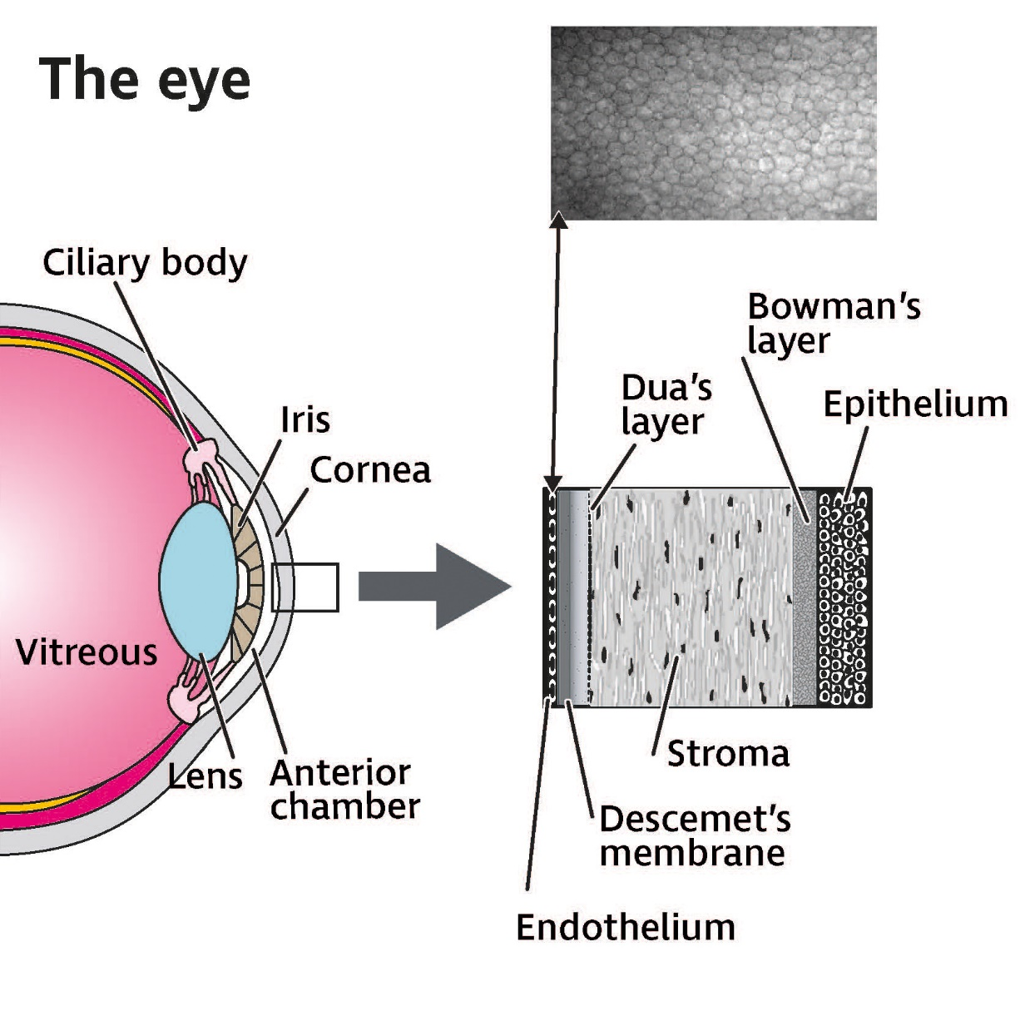
Diagram shows the different layers of the cornea as detailed below.

The cornea is made up of six layers starting from the outer to the innermost layer:
- Epithelium – the outermost protective skin of the cornea.
- Bowman's membrane – this second layer is tough and difficult to penetrate further protecting the eye.
- Stroma – the thickest central layer of the cornea, consisting of mainly water, collagen fibres and other connective tissue that give the cornea its strength, elasticity and optical clarity.
- Pre-Descemet’s (or Dua’s) layer – recently described as a thin fourth layer, very tough and strong, mainly containing collagen.
- Descemet's membrane – a thin yet strong inner membrane layer that also acts as a protective layer.
- Endothelium – the innermost layer consisting of specialised cells that maintain a healthy balance of fluid within the cornea and prevent the cornea from swelling.

Why have I developed FECD?
Usually, FECD is sporadic which means that there is no family history of the condition. FECD can also be inherited, meaning that it can be passed down from parents to children. If either of your parents have FECD, there may be a 50 percent chance of developing the condition yourself. This is known as autosomal dominant inheritance.

As no treatment is required unless you are having problems with your vision, family members don’t need to be screened and don’t need any special additional care for their eyes other than regular routine eye examinations by their high street optometrist (optician). The condition only affects the eyes and no other parts of the body.

How does FECD affect your vision?
FECD mainly affects the single layer of cells that line the back part of the cornea called the endothelium. The main function of the endothelium is to maintain the correct amount of fluid within the cornea, pumping out excess fluid and keeping the cornea clear for you to “see”.

A small number of endothelial cells are lost during the normal ageing process. This does not normally cause any changes in your vision. In FECD however, this process speeds up with more cells than usual being lost. Eventually the endothelium stops working properly, and fluid builds up in the cornea leading to increased corneal thickness and swelling (oedema). Your vision then becomes cloudy and blurred. For many people with FECD, the condition progresses slowly, and they don’t develop any problems with their vision.

One of the first symptoms you may notice, is more blurred vision first thing in the morning when you wake up. The cornea naturally swells slightly when your eyes are closed during sleep, and this can be worse if you have FECD. You may find that your vision improves as the day goes on. This improvement happens because when your eyes are open, the fluid in the cornea can evaporate from the surface of the cornea. The blurriness can get worse when the humidity level is high.

Extra fluid in your cornea can make light uncomfortable and you may find it harder to see when it’s very bright. You may also experience light sensitivity (glare) and see halos around lights. This can be more noticeable at night, for example, when you’re driving.

FECD can sometimes lead to deposits called guttata appearing at the back of the cornea. These are tiny, drop-like irregular lumps in the corneal endothelium which can only be seen with a special microscope. They can cause light to be scattered, causing symptoms of glare.

The fluid in your cornea may also affect how well you can pick objects out against their backgrounds, particularly if there is not a lot of contrast between them so they appear to blend together. For example, you may have difficulty seeing white rice on a white plate. This is described as having reduced contrast sensitivity. You may also find that colours appear to be washed-out. If one eye is more affected than the other, picking up objects might also become difficult. This is because reduced vision in one eye can cause loss of depth perception and 3-dimensional vision.

In the longer term
Eventually, some people may find their vision no longer improves as the day goes on. This is because they have lost a substantial number of endothelial cells. Fluid now collects in the cornea causing its layers to remain swollen all the time.

The epithelium (the outermost corneal layer) has many nerve endings in it. When this layer is swollen, your eyes can feel gritty and painful.

If your cornea is swollen, you may also develop blisters on its surface. These are known as epithelial 'bullae'. If this happens, it is known as bullous keratopathy. If a blister bursts, you may experience sharp pain and discomfort.

These blisters can also cause increased light sensitivity, glare and halos around lights as well as making your eyes water and feel very sore as if there is a foreign body in the eye. If the blisters do not get better, they can cause corneal scarring, which will reduce vision in the affected eye. Blisters can make the shape of the cornea uneven affecting the way light is focused into the eye, causing problems with your vision. For some people, a corneal transplant may be suggested by your ophthalmologist (hospital eye doctor), particularly if your FECD is becoming more severe and treatment of your symptoms is no longer helpful.

For most people, FECD is a slow developing condition and it’s possible to go for a long time without experiencing any of the symptoms.

How is FECD diagnosed?
FECD is quite a common corneal dystrophy, developing gradually over 10 to 20 years and generally involves both eyes. While some people may never have any real problems with their vision, others may have symptoms which affect their sight.

The presence of FECD may be found incidentally during a routine eye examination by your optometrist. If your vision is reduced, the optometrist will look for reasons why this has happened by examining all the structures of the eye in detail. An optical microscope called a slit lamp biomicroscope is used to check your cornea in detail to look for subtle changes in the appearance of endothelial cells.

Your optometrist may mention FECD to you because they can see changes to the back layer of the cornea. This does not mean you will go on to have problems with your vision, and nothing needs to be done if you are seeing well. How much the condition can affect your vision, however, will vary from person to person.

If your FECD symptoms are causing problems with your vision and affecting your daily activities, your optometrist may refer you to be seen by an ophthalmologist in the eye clinic for specialist advice. Your ophthalmologist will thoroughly examine your eyes and sometimes may even use a special device called the specular microscope to take high magnification pictures of the cornea. This means that the ophthalmologist can measure the number of endothelial cells present in your cornea. The clinical signs indicative of FECD are a reduction in the number of endothelial cells, an increased irregularity of cell shape and size, and the appearance of corneal guttata. Your ophthalmologist may also measure your corneal thickness (pachymetry), to detect any increase that might show there is corneal swelling present.

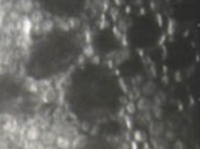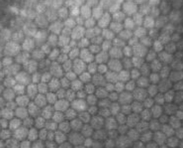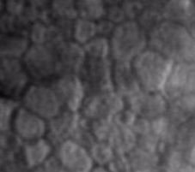
Normal

- The photos above show three images of the endothelium using a specular microscope.
- The left image shows a healthy endothelium; cells are arranged in a regular pattern of hexagonal shapes.
- The middle image shows an endothelium affected by FECD; the endothelial cells become more irregular in shape and size.
- The right image (red arrow) shows corneal guttae; these are produced by stressed endothelial cells which over time lead to corneal swelling.

Can I do anything to slow down the development of FECD?
At present there is no evidence that any treatment, supplements or changes to your diet can prevent FECD from developing or help to slow down its progress. There are also no treatments that can prevent or reverse the loss of endothelial cells of the cornea but the symptoms of FECD can be treated.

How are the symptoms of FECD treated?
If FECD isn’t affecting your sight or is only causing mild symptoms, then you won’t need any treatment. Instead, your eyes may be routinely examined to monitor how the condition progresses over time. If your vision is affected mainly in the mornings, clearing through the day, then your ophthalmologist may recommend using sodium chloride drops or ointments which might help to remove excess fluid in some cases. Sodium chloride may not help every patient with a swollen cornea.

If you experience light sensitivity due to FECD, you can limit the amount of light entering your eyes by using tinted glasses. The level of tint is largely a matter of personal choice as well as a balance between being dark enough to help with glare while still allowing enough light to make the most of your vision. Some people may find light activated sunglasses or photochromic lenses helpful. These lenses turn darker in brighter sunlight, reducing light sensitivity. Polarised lenses may also help as they minimise glare reflected from flat surfaces such as water. Your optometrist or dispensing optician will be able to offer more advice about this.

If you’re driving, it’s important that you have a discussion with your optometrist about the level of tint in your glasses that is suitable for you to use and meets the Driver and Vehicle Licensing Authority (DVLA) regulations as well. If glare is an issue while driving at night, your optometrist will be able to advise whether using clear prescription lenses with an anti-reflection coating can be helpful for you. More information about coping with light sensitivity and glare can be found in our Light sensitivity (photophobia) factsheet on our website at rnib.org.uk/eyehealth or by calling our Helpline.

If corneal blisters (bullous keratopathy) develop, then you may be prescribed medicines to help with the pain or discomfort they cause. You may also need to wear soft therapeutic contact lenses day and night. These act as bandages that relieve pain by protecting exposed nerve endings on the surface of your cornea and encouraging the burst blisters to heal.

Corneal transplant for FECD
If the changes to your sight are starting to cause difficulties in your daily activities, your ophthalmologist may recommend that you have a corneal transplant. Corneal transplants can successfully treat FECD.

A corneal transplant is surgery to remove all or part of a damaged cornea and replace it with healthy, clear corneal tissue from a healthy donor. It’s possible to carry out transplants which replace all or only some layers of the cornea with healthy donor tissue. A corneal transplant is often referred to as keratoplasty or a corneal graft.

Your ophthalmologist would be able to explore with you when it may be suitable for you to have a corneal transplant.

Types of corneal transplants
The common types of corneal transplant procedures to treat FECD only replace the innermost layers of the cornea. These selective corneal transplants are known as “endothelial keratoplasty”.

The commonest endothelial keratoplasty transplant used for FECD is an endothelial keratoplasty transplant called Descemet's membrane endothelial keratoplasty (DMEK) where only the endothelium and the Descemet's membrane from a donor cornea is used. By transplanting a thin layer of tissue in DMEK, recovery times are faster than for other forms of corneal transplant (DSEK or DSAEK), the visual results are better, and the rejection risk is lower at only one percent for DMEK, compared to seven to eight percent for DSAEK.

The other main type of endothelial keratoplasty transplant used for FECD is called Descemet's stripping endothelial keratoplasty, often shortened to DSEK. This procedure is sometimes also known as “DSAEK” where the “A” stands for automated. In DSEK you receive a new endothelium, Descemet's membrane as well as some of the stroma from a donor cornea.

The damaged corneal layer is removed through a small incision. Then the new healthy tissue is put in place. Just a few stitches, if any, are needed to close the incision and are usually removed around two to four weeks after the surgery. The new layers of donated tissue are kept in place with a temporary air bubble, which acts as a bandage, holding the transplanted corneal layers in place. This is either removed at the end of the surgery or left in place to help with the healing process. If this is the case, you may be asked to lie on your back as much as possible in the first few days after surgery and eventually the air bubble will be harmlessly absorbed into your eye.

DSEK and DMEK generally have short recovery times, usually only a few weeks or months and the risk of having the new corneal graft being rejected after surgery is also low. However, it can take up to six months until full improvement in your vision is seen.

Less commonly in FECD, if the stroma is scarred, someone might need to have a full thickness transplant or “penetrating keratoplasty” (PK) where your cornea is replaced by a donor cornea. This type of transplant requires stitches and generally has a recovery period of about 18 months. The rejection risk of this procedure is usually in the range of 12-13 percent.

If you need a transplant, the type that may be suitable for you is likely to depend on the layers of your cornea affected by FECD.

How well do corneal transplants work?
Both endothelial keratoplasty and penetrating keratoplasty procedures work very well in FECD as the condition does not come back in the transplant.

Most people notice an improvement in their sight in the first six months after transplant surgery. People who have had endothelial keratoplasty are likely to experience improvements in their sight sooner than people who have had penetrating keratoplasty. This is because endothelial keratoplasty is a “keyhole” surgery which is quick to heal and usually does not require any stitches or very few stitches.

Corneal transplant is an effective treatment. However, sometimes a transplant may need to be repeated if there are problems with transplant rejection. While FECD does not re-occur in the new corneal graft, the new cells can still fail for other reasons including rejection, trauma, infection, natural loss of cells for example. Corneal graft rejection can occur when your body’s defence or immune system recognises the transplanted tissue as foreign. It is usually possible to treat corneal transplant rejection with anti-inflammatory drops, which reduce swelling. If the graft fails, the cornea will again become swollen with clouding of vision. However, frequent problems with rejection may lead to the need for repeat transplant surgery.

Although rejection is a risk and can affect about one in five of all transplants, the risk of rejection is reduced by using steroid eye drops. Across all types of corneal transplant, 75 percent will last at least five years, and more than 50 percent of transplants will last up to ten years. Advantages of endothelial keratoplasty in addition to rapid recovery include lower rejection rates and relatively easy repeat surgery if this is required.

For more information about the different types of corneal transplant surgery or for our Corneal transplant factsheet visit rnib.org.uk/eyehealth or call our Helpline.

Cataracts and FECD
Both FECD and cataracts are more common as you get older, and this means that they can often happen together, however, they do not interact and do not make each other worse.

Cataracts are a very common eye condition. As you get older, the lens inside your eye gradually changes and becomes less clear and cloudy, this is known as a cataract.

Over time a cataract can get worse, gradually making your vision mistier. Cataracts can be treated with a straightforward operation to remove the cloudy lens and replace it with a new artificial one, enabling you to see clearly again. Further information about cataracts and cataract surgery can be found in our Understanding Cataracts booklet, visit rnib.org.uk/eyehealth or call our Helpline for a copy.

Whilst cataract surgery is usually very successful, any surgery to the eye, including cataract surgery, can further reduce the number of healthy corneal endothelial cells in FECD. This may result in corneal decompensation (corneal swelling and cloudiness) and it sometimes needs to be followed up by, or combined with, an endothelial keratoplasty procedure. Due to this risk, it is important for someone with FECD to have their cornea examined carefully before cataract surgery is performed.

Sometimes your ophthalmologist may decide that you need to have both cataract surgery and corneal transplant at the same time. Two separate surgeries are combined into one procedure. In some cases, it may be safer to let the eye settle from cataract surgery first, then have endothelial keratoplasty afterwards.

If you’re concerned about cataract surgery worsening FECD, it would be important to discuss this with your ophthalmologist.

Other precautions
If you have FECD and ocular hypertension (high eye pressure), your ophthalmologist may recommend glaucoma eye drops to reduce your high eye pressure. High eye pressure can damage the corneal endothelium potentially making your FECD worse.

If you are considering having refractive surgery (surgery to reduce short-sightedness or long-sightedness) and have been diagnosed with FECD, it is very important that you discuss the condition with your ophthalmologist before surgery. Refractive surgery often involves corneal surgery or lens removal (such as you would have in cataract surgery) and therefore it is important that your ophthalmologist considers the effect this may have on your FECD.

Can I still drive?
Many people can continue driving if their vision is unaffected by FECD and they meet the visual requirements of DVLA for driving. However, if you have any eye condition that may affect your vision in both eyes, you are required by law to inform the DVLA. Ask your optometrist or ophthalmologist for advice about whether your sight meets the DVLA standards and whether you can continue driving.

Coping
It’s completely natural to be upset when you’ve been diagnosed with an eye condition, and it’s normal to find yourself worrying about the future and how you will manage with a change in your vision.

It can sometimes be helpful to talk over these feelings with someone outside of your circle of friends or family. Sometimes it can help to talk about your feelings or share your experience with people who may have had similar experiences. At RNIB, we can help with our telephone Helpline and our Sight Loss Advice service and Counselling and Wellbeing service. Your general practitioner (GP) or social worker can also refer you for counselling, if you feel this may be helpful.

Help to see things better
Many people with FECD find that they don’t have many problems with their vision. If you are having trouble with your vision, then there is much that can be done to help you make the most of your remaining vision and adapt to any changes.

This may mean making things bigger, using brighter lighting or using colour to make things easier to see. We have a series of leaflets with helpful information on living with sight loss, including how to make the most of your sight. You can find out more about our range of titles by calling our Helpline. Our website also offers a lot of practical information about adapting to changes in your vision and products that make everyday tasks easier.

You should ask your ophthalmologist, optometrist or GP about low vision aids and having a low vision assessment. During this assessment you’ll be able to discuss the use of magnifiers and aids to see things more clearly.

Local social services should also be able to offer you information on being safe in your home and getting out and about safely. They should also be able to offer you some practical mobility training to give you more confidence when you are out.

Further help and support
If you have questions about anything you’ve read in this factsheet, please get in touch. Whether you have just been diagnosed with FECD or have been living with it for a while, at RNIB, we are here to help and support you at every step.

Other useful contacts

Driver and Vehicle Licensing Agency (DVLA)
Drivers' medical enquiries
Swansea SA99 1TU
Telephone: 0300 790 6806
Website: gov.uk/driving-medical-conditions

Fuchsfriends UK
A support group for people living in the UK who are affected by Fuchs Corneal Dystrophy
Website: fuchs-dystrophy.org.uk

We value your feedback
You can help us improve our information by letting us know what you think about it. Is this factsheet useful, easy to read and detailed enough – or could we improve it? We would also like your views on the pictures and diagrams, are they appropriate, helpful and are there places where a diagram might have helped?

Send your comments to us by emailing us at eyehealth@rnib.org.uk or by writing to the Eye Health Information Service, RNIB, 154a Pentonville Road, London, N1 9JE.

How we can help

RNIB Helpline
There is more information about equality and employment on our website, visit rnib.org.uk/equality-employment.

If you need someone who understands sight loss, call our Helpline on 0303 123 9999, say “Alexa, call RNIB Helpline” to an Alexa-enabled device, or email helpline@rnib.org.uk. Our opening hours are weekdays from 8am – 8pm and Saturdays from 9am – 1pm.

Sight Advice FAQ
Sight Advice FAQ answers questions about living with sight loss, eye health or being newly diagnosed with a sight condition. It is produced by RNIB in partnership with other sight loss organisations. sightadvicefaq.org.uk

Connect with others
Meet or connect with others who are blind or partially sighted online, by phone or in your community to share interests, experiences and support for each other. From book clubs and social groups to sport and volunteering, our friendly, helpful and knowledgeable team can link you up with opportunities to suit you. Visit rnib.org.uk/connect or call 0303 123 9999.

This factsheet has been written by the RNIB Eye Health Information service. Our factsheets have been produced with the assistance of patient and carer input and up-to-date reliable sources of evidence. The accuracy of medical information has been checked by medical specialists. If you would like a list of references for any of our fact sheets, please contact us at eyehealth@rnib.org.uk.

All our factsheets are available in a range of formats including print, audio and braille.

RNIB is a member of the Patient Information Forum (PIF) and have been certified under the PIF TICK quality mark scheme.

Last updated: April 2024
Next review: April 2027

