Debt

If you are in debt or are struggling financially there are many organisations that can provide you advice and practical support.

The first thing to do would be to seek independent advice to explore not only how to manage your debts but also to check if you are missing out on any income or benefit entitlement.

Citizen’s Advice Bureau (CAB)
Well known for providing independent and free information and support.
Visit their website for information on a range of topics or call them to find out where the nearest office is from where you can get advice over the telephone or in person.

England and Wales
citizensadvice.org.uk
England: 03444 111 444
Wales: 03444 77 2020

Scotland
citizensadvice.org.uk/scotland
0808 800 9060

Northern Ireland
citizensadvice.org.uk/northern-ireland
0800 028 1881

National Debtline
A Helpline that provides free confidential and independent advice on how to deal with debt problems as well as a detailed website with useful sample letters and other resources to help you deal with your debts yourself. It is part of The Money Advice Trust, a registered charity.

nationaldebtline.co.uk
0808 808 4000

Step Change Debt Charity
Are a charity providing debt advice and can also provide a free debt management plan.
stepchange.org
0800 138 1111

The Money Advice Service
A free and independent service set up by the Government may be able to
help. They offer information on a range of subjects including:
- how to cope with changing circumstances, like a sudden drop in income
- getting the most out of your budget
- saving for a special event or a rainy day
- borrowing wisely
- understanding tax and welfare benefits.

If they don’t have the answers, they will help you to find them elsewhere.
This will include signposting you to specialist advice on debt or pensions or to regulated financial advice.

moneyadviceservice.org.uk
0800 138 7777

Although RNIB cannot provide debt or financial advice we can offer you a benefit check so if you would like this assistance please contact the RNIB Helpline on 0303 123 9999.

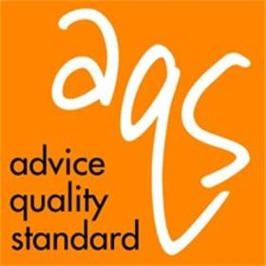
© RNIB January 2019

